**BASELIOS POULOSE II CATHOLICOS COLLEGE**

**BASELIOS MOUNT, PIRAVOM**

**Re-accredited with ‘A’ Grade by NAAC**

**(Affiliated to Mahatma Gandhi University)**

**DEPARTMENT OF COMPUTER APPLICATIONS**

**2022-23**

**Project Report**

**On**

**SV JEWELLERS**

**(Online Jewellery Website)**

**BASELIOS POULOSE II CATHOLICOS COLLEGE**

**BASELIOS MOUNT, PIRAVOM**

**Re-accredited with ‘A’ Grade by NAAC**

**(Affiliated to Mahatma Gandhi University)**

**DEPARTMENT OF COMPUTER APPLICATIONS**

**Project Report**

**on**

**SV JEWELLERS(Online Jewellery website)**

**Submitted in partial fulfillment of the**

**Requirements for the award of the degree of**

**BACHELOR OF COMPUTER APPLICATION**

**Guided by: Dr. Dhanya Job Submitted by:**

**(Dept. of Computer Applications) V Sooraj**

**(210021093801)**

**BASELIOS POULOSE II CATHOLICOS COLLEGE**

**BASELIOS MOUNT, PIRAVOM**

**Re-accredited with ‘A’ Grade by NAAC**

**(Affiliated to Mahatma Gandhi University)**

**DEPARTMENT OF COMPUTER APPLICATIONS**

Certificate

*This is to certify that the project entitled “ SV JEWELLERS” submitted in partial*

*fulfillment for the award of the degree of BACHELOR OF COMPUTER*

*APPLICATION is a bonafide report of the project done by V SOORAJ*

*(Reg no: 210021093801) during the year 2022-23*

**Internal Guide: Head of the department**

**Dr. Dhanya Job Dr. Anu Paul**

**Examiner: 1.**

**College Seal Department Seal**

**DECLARATION**

*I hereby declare that this project work entitled “SV Jewellers” is a record of original work done by me under the guidance of* ***Dr. Dhanya Job,*** *Assistant Professor, Department of Computer Applications and the work has not formed the basis for the award of any degree or diploma or similar title to any candidate of any university subject.*

Internal Guide: Signature of Student

**Dr. Dhanya Job**

**ACKNOWLEDGMENT**

**ACKNOWLEDGMENT**

At the outset, I thank God Almighty for making endeavour a success.

I express my gratitude to Dr. Santhosh P Kuruvila, Principal, Baselios

Poulose II Catholicos College, for providing me with adequate facilities, ways and means by which I was able to complete the project work. I express my sincere thanks to my internal guide Dr. Dhanya Job, who guide me properly from the beginning to the end of my project. With immense pleasure I take this opportunity to record out sincere thanks to my Guide and Head of the Department Dr. Anu Paul Department of Computer Applications in examining the draft of this project and suggestions and modifications.

Last but not the least, I also express my gratitude to all other members of the faculty and well wishers who assisted me in various occasions during the project work.

**:- V Sooraj**

**ABSTRACT**

**ABSTRACT**

The web application entitled “SV Jewellers”

Is a platform where the display of gold and silver products of the jewellers, customers can also buy the products from the web application.

For administrators, the platform offers a robust and user-friendly dashboard, facilitating the management of product listings, inventory, and customer interactions. It also provides real-time analytics and insights, aiding in decision-making and business growth strategies. The admin interface streamlines inventory management, allowing for easy addition, updating, and removal of jewellery products.

Customers, on the other hand, enjoy a seamless and personalized shopping experience on the SV Jewellers e-commerce platform. The user-friendly interface allows them to explore a wide range of jewellery collections, view high-quality images, and make informed purchase decisions. Customers can create accounts, track their orders, and access a variety of secure payment options, ensuring a convenient and trustworthy shopping.

Moreover, the platform enhances customer engagement with interactive features like product reviews, ratings, and a responsive customer support system,assisting customers in making well-informed choices.

SV Jewellers' e-commerce platform bridges the gap between administrators and customers, offering a comprehensive solution for both. This innovative digital platform not only simplifies business operations for administrators but also provides a seamless, enjoyable, and secure shopping experience for customers, reaffirming SV Jewellers' commitment to excellence in the ornamental jewellery industry

LIST OF FIGURES

|  |  |  |
| --- | --- | --- |
| **SI.No** | **Figure Name** | **Page Number** |
| **1** | Zeroth level DFD SV JEWELLERS | 53 |
| **2** | First level DFD User | 54 |
| **3** | First level DFD Admin | 55 |
| **4** | Second level DFD Manage Ornaments | 56 |
| **5** | Second level DFD Generate report | 57 |
| **6** | Second level DFD Buy Products | 57 |
| **7** | Second level DFD Make Orders | 58 |
| **8** | Sample interface design | 60 |
| **9** | Sample interface design | 61 |
| **10** | Pie chart sales report | 63 |
| **11** | Order details | 63 |
| **12** | Unit testing | 81 |
| **13** | Unit testing result | 81 |
| **14** | Integration testing | 82 |
| **15** | Integration testing result | 83 |
| **16** | Integration testing result | 83 |

|  |  |  |
| --- | --- | --- |
| **17** | Ornament insertion | 85 |
| **18** | Ornament insertion validation | 86 |
| **19** | Product image validation | 86 |
| **20** | login validation | 87 |
| **21** | Email Validation | 87 |
| **21** | Product id exist validation | 88 |
| **23** | Login page | 93 |
| **24** | Dashboard-user | 93 |
| **25** | Dashboard remaining | 94 |
| **26** | Shop page | 94 |
| **27** | Shop-product page | 95 |
| **28** | Collections page | 95 |
| **29** | Cart page | 96 |
| **30** | Product details | 96 |
| **31** | About us | 97 |
| **32** | User profile | 97 |
| **33** | GST Bill | 98 |
| **34** | Delivery address page | 98 |
| **35** | Card payment | 99 |
| **36** | Payment successful | 99 |
| **37** | Admin dashboard | 100 |
| **38** | Orders listed | 100 |
| **39** | Product details of order | 101 |
| **40** | Product insertion | 101 |

|  |  |  |
| --- | --- | --- |
| **41** | Pie chart sales report | 102 |
| **42** | User details mail-individual | 102 |
| **43** | About us updation page | 103 |
| **44** | Order report over two dates | 103 |
| **45** | User details | 104 |
| **46** | Gold products already inserted | 104 |
| **47** | Silver products already inserted | 105 |

LIST OF TABLES

|  |  |  |
| --- | --- | --- |
| SI.no | Table name | Page Number |
| 1 | tbl_aboutus | 44 |
| 2 | tbl_address | 44 |
| 3 | tbl_cart | 45 |
| 4 | tbl_cartdetails | 45 |
| 5 | tbl_goldimage | 46 |
| 6 | tbl_silverimage | 46 |
| 7 | tbl_goldproduct | 46 |
| 8 | tbl_silverproduct | 47 |
| 9 | tbl_jewelery_orders | 48 |
| 10 | tbl_productsalesreport | 49 |

|  |  |  |
| --- | --- | --- |
| 11 | tbl_user | 50 |
| 12 | Data flow diagram symbols | 52 |
| 13 | Example test cases | 89 |

TABLE OF CONTENTS

**Acknowledgment iv**

**Abstract v**

**List Of Tables vi**

**List Of Figures vii**

1. **Introduction………………………………………………………15**
   1. Background and Motivation………………………………….15
   2. The Proposed System…………………………………………17
   3. Project Scope…………………………………………………18
      1. Limitations of Existing System…………………………18
      2. Advantages of Proposed System…………………….....19
2. **System Analysis…………………………………………………..20**
   1. Introduction…………………………………………………...20
   2. Stakeholders of this project…………………………………...21
      1. Site Administrator………………………………………21
      2. Customer………………………………………………..23
   3. Software Requirement Specifications…………………………25
      1. Site Administrator……………………………………….25
      2. Customer…………………………………………………26
   4. Feasibility Study……………………………………………….27
   5. Software Development Life Cycle……………………………..30
   6. Hardware and Software Requirements…………………………32
      1. Software Specifications…………………………………..32
         1. Microsoft Visual Studio code………………………33
         2. MySQL……………………………………………..33
         3. Windows11…………………………………………34
      2. Hardware Requirements…………………………………...35
3. **System Design………………………………………………………37**
   1. System Architecture……………………………………………..37
   2. Module Design…………………………………………………...38
   3. Database Design………………………………………………….40
      1. Normalization……………………………………………..42
      2. Table Structure……………………………………………43
      3. Data Flow Diagram……………………………………….50
         1. Introduction to Data Flow Diagram………………..50
         2. Data Flow Diagram………………………………...53
   4. Interface Design…………………………………………………58
      1. User Interface screen design………………………………60
      2. Output Design……………………………………………..62
4. **Implementation……………………………………………………64**
   1. Coding Standard…………………………………………………64
   2. Sample Code…………………………………………………….65
5. **Testing……………………………………………………………….79**
   1. Test Cases………………………………………………………..79
      1. Unit Testing……………………………………………….80
      2. Integration Testing………………………………………...82
      3. Blackbox Testing………………………………………….84
      4. Whitebox Testing………………………………………….84
      5. Validation Testing…………………………………………85
      6. User Acceptance Testing………………………………….88
   2. Test Case Documentation……………………………………….89
6. **Conclusion………………………………………………………...91**
   1. Future Enchancements…………………………………………..91
7. **Appendix………………………………………………………….93**
   1. Screenshots………………………………………………………93

1.**INTRODUCTION**

**1.1 BACKGROUND AND MOTIVATION**

Jewellery has been an integral part of human culture for centuries, symbolizing beauty, elegance, and individuality. Our jewellery website is dedicated to bringing the timeless allure of exquisite pieces to a global audience. We understand that jewellery is more than just ornaments; it carries sentiments, tells stories, and makes moments unforgettable. With this understanding, we aim to bridge the gap between traditional craftsmanship and modern technology, making the jewellery shopping experience convenient, enjoyable, and accessible to all. We prioritize trust and transparency. Our website showcases the certifications and quality standards that our jewellery adheres to, guaranteeing the authenticity and value of your purchase. Each jewellery piece comes with a detailed certificate of authenticity and care instructions, ensuring that you enjoy your purchase for years to come. Our commitment to combining tradition and technology means that we make it easier for you to find the perfect piece, make informed decisions, and stay connected with us. We look forward to sharing this exciting journey of jewellery exploration with you and ensuring that you find jewellery that reflects your unique style and stories. At our jewellery website, we take pride in the artistry and craftsmanship behind each piece. Our team of experienced artisans meticulously handcrafts every jewellery item, ensuring attention to detail and quality. Whether it's the precision of setting gemstones, the intricacy of filigree work, or the elegance of metalwork, our jewellery embodies the skill and passion of these artisans. We are committed to responsible and ethical sourcing of materials for our jewellery. Our gemstones are sourced from reputable suppliers who adhere to strict ethical standards. We also focus on sustainability by using recycled metals and minimizing our environmental footprint. Your peace of mind is essential to us. Our website offers a secure shopping experience with multiple payment options and a straightforward checkout process. We take data security seriously and ensure that your personal information is kept safe. Your peace of mind is essential to us. Our website offers a secure shopping experience with multiple payment options and a straightforward checkout process. We take data security seriously and ensure that your personal information is kept safe.

**1.2 PROPOSED SYSTEM**

This is a project designed for a jewellery shop which have the ability to shop the ornaments online and display the ornament stock to the public. The project is designed particularly for jewelleries . The customers can surf through the website and buy different varieties of ornaments and the product will be delivered to their door step if order is placed .The project aims to enhance the functionality of the website and provide an exceptional user experience for customers looking to purchase jewellery. The primary objective is to create an easy-to-navigate, user-friendly platform where customers can explore and purchase a wide range of jewellery items .The Customers for this websites are the Admin and End user ,the Customers can login to the website and can see the real time gold/silver rates also they can surf through the products displayed on the stocks of the jewellery .Customers can view the products and add the product to the cart ,once the products are added to the cart they can opt for checkout procedures and when the proceed button is clicked the original GST rate included bill can be generated, further additional information like address to be delivered can be provided on upcoming pages and payment can be made. Once the payment is made ,the order will be placed and the user can view it on the user side page. In the Admin side admin can view the orders made by the Customers and can accept and reject the orders, once the order is accepted the order will be placed and the stock will be deducted from the core database.in the admin Side the admin can view the sales report in pie chart format, admin can view the orders placed by the customers, can insert the new products also can delete the products , Admin can mail to the Customers logged on to the website mailing the offer details or any other festive offers too. Admin have the authority to update the gold/silver rates daily and that will be reflected on the products total rates too. This proposed system should help improve the functionality and user experience on your jewellery website, SV Jewellers, attracting more customers and facilitating smooth transactions. Make sure to prioritize the security of customer data and provide excellent customer support to build trust and loyalty.

**1.3 PROJECT SCOPE**

**1.3.1 LIMITATIONS OF EXISTING SYSTEM**

* **Fixed gold/silver rates**

The existing system for the jewellery websites have a fixed rate for all the products daily ,but as we know that the gold/silver rates are rapidly changing daily so as to get the benefit of the rate changes the admin should edit the rates daily

* **Security Concerns:**

Online transactions, including the sharing of personal and financial information, can raise security concerns, such as the risk of fraud or data breaches. To address this limitation, online jewellery retailers must implement secure payment gateways and robust security measures.

* **Inaccurate Representations:**

Online product images may not always represent the actual size of jewellery items accurately. To mitigate this limitation, retailers should provide multiple images, including close-ups and images of jewellery being worn. Detailed measurements should also be available.

* **Shipping Delays:**

Transparency in shipping times and options is vital. Retailers should offer various shipping methods with estimated delivery times and provide tracking information. They should also clearly communicate any potential delays, such as during busy holiday seasons.

**1.3.2 ADVANTAGES OF PROPOSED SYSTEM**

* **Daily rate changes**

The proposed system has the option to change the rates of gold/silver daily by the Admin .This option will help the Customers get the product at a better price daily

* **24/7 Accessibility:**

The online platform allows customers to browse and shop for jewellery items at any time, providing round-the-clock accessibility and convenience for both local and international customers.

* **Extensive Product Range:**

SV Jewellers can showcase a vast range of jewellery products without the limitations of physical space, giving customers access to a wide selection of items, including rings, necklaces, bracelets, earrings.

* **GST bill Generation**

GST bill can be generated for the products that are bought from the jewellery .The bill can be downloaded to the Customers machine during the time of payment

**2.SYSTEM ANALYSIS**

**2.1 INRODUCTION**

System analysis is an iterative and collaborative endeavor that encompasses various methodologies and techniques, such as data modeling, process flow analysis, and user interviews. It is a multidisciplinary field that blends business acumen, technology expertise, and communication skills to create solutions that meet the ever-evolving demands of modern organizations. This process involves a comprehensive study of the current system, the gathering of user requirements, and the creation of detailed specifications for system design and development. System analysts play a pivotal role in bridging the gap between business needs and technical solutions, ensuring that the resulting system is efficient, effective, and capable of delivering value to stakeholders. In this digital age, system analysis is more important than ever, as it underpins the development of cutting-edge technologies, the enhancement of business processes, and the seamless integration of systems to drive innovation and productivity. This introduction to system analysis sets the stage for a deeper exploration of its principles, methods, and applications in the design and improvement of systems across various domains.

There are a number of different approaches to system analysis. When a computer based information system is developed, systems analysis would constitute the following steps:

* The development of a feasibility study, involving determining whether a project is economically , technologically and operationally feasible.
* Conducting fact-finding measures, designed to ascertain the requirements of the system's end-Customers. These typically span interviews, questionnaires, or visual observations of work on the existing system

In conclusion, system analysis is a fundamental discipline that plays a pivotal role in understanding, optimizing, and innovating complex systems across various domains. Through a structured and methodical approach, system analysts examine existing systems, gather requirements, and design solutions that enhance efficiency, effectiveness, and alignment with organizational objectives. In a world where adaptability, efficiency, and technology integration are essential for success, system analysis remains a critical enabler. It empowers organizations to stay ahead of the curve, respond to market changes, and leverage emerging technologies to their advantage. As the digital landscape continues to evolve, system analysis will continue to evolve with it, ensuring that organizations can thrive and remain competitive.

**2.2 STAKEHOLDERS OF THIS PROJECT**

**2.2.1 SITE ADMINISTRATOR**

The site administrator is a pivotal stakeholder within the online jewellery business, holding a multifaceted role that significantly influences the platform's functionality and overall success. Their responsibilities encompass a range of crucial tasks that are essential for the smooth operation of the e-commerce platform.

One of the core functions of the site administrator is the management of the product catalog . They have the authority to add new products and remove outdated or unpopular items. This ensures that the product offerings remain current, reflecting the latest jewellery trends and customer preferences. By regularly updating the product catalog , the administrator helps to maintain the platform's appeal to customers and keeps it competitive in the jewellery market.

Furthermore, the administrator takes on a crucial role in enhancing security and understanding user behaviour. They can access detailed logs that record Customers' login activities. This not only serves as a security measure, helping to identify and mitigate any suspicious or unauthorized access, but it also provides valuable insights into user engagement and preferences. By monitoring login details, the administrator can tailor the platform's user experience to better serve the customers.

The ability to view user orders and their order histories is another vital aspect of the administrator's role. This feature enables them to track individual customer purchasing patterns and preferences. It also aids in addressing customer inquiries or resolving potential issues related to orders. By having this oversight, the administrator can ensure that customers receive a seamless and personalized experience.

In addition, the site administrator is equipped with the capability to generate reports that are essential for strategic decision-making. They can produce product reports, which offer insights into the performance of various items, helping to identify top sellers and underperforming products. Order reports provide valuable data on sales trends, helping the business to adapt to customer demands and market fluctuations. These reports play a pivotal role in inventory management and product development strategies.

Customer engagement and marketing are also within the purview of the administrator. They have the authority to send email communications to Customers, providing updates, exclusive offers, and information about new arrivals. This not only fosters customer loyalty but also drives sales and keeps customers informed about the latest offerings.

Furthermore, the site administrator takes on the essential responsibility of managing stock levels. This involves monitoring inventory to prevent stockouts and overstock situations, ensuring that customers have access to their desired items when they need them. Effective stock management is critical in meeting customer expectations and optimizing the business's operational efficiency.

Finally, the administrator is tasked with staying informed about market dynamics. They need to manage the gold and silver rates, which can be highly volatile, ensuring that the platform's pricing remains competitive and reflective of current market values. This responsibility helps the business remain adaptable in a rapidly changing market.

In essence, the site administrator is a central figure in the online jewellery business, working behind the scenes to manage products, oversee user activities, analyse data, engage customers, maintain stock levels, and respond to market dynamics. Their role is critical in providing a seamless and satisfying experience for both the business and its customers.

**2.2.2 CUSTOMERS**

The site Customers, as key stakeholders in the online jewellery platform, play a central role in driving the success and functionality of the website. These individuals are the heart of the e-commerce experience, and their interactions with the platform are essential to its continued growth and development.

Customers have the privilege of logging onto the website, accessing the rich catalog of jewellery products offered. They can seamlessly browse through a wide range of items, exploring diverse styles and designs, all from the comfort of their own screens. This easy accessibility ensures that Customers can explore and select jewellery items that align with their preferences and requirements.

One of the standout features available to Customers is the ability to add desired products to their shopping cart. This functionality allows Customers to create a personalized selection of items they wish to purchase. Whether it's a stunning engagement ring, an elegant necklace, or a trendy bracelet, the cart serves as a virtual shopping basket, making the entire shopping process convenient and flexible.

Additionally, Customers have the ability to view the contents of their cart in detail. They can check the cart's contents, review the selected items, and assess the total cost. This transparency ensures that Customers have full control over their choices and can make any necessary adjustments before proceeding with the purchase.

Another valuable capability for Customers is the ability to edit their profile details. This feature allows them to manage their personal information, update contact details, and maintain accurate records. An up-to-date profile is essential for seamless transactions and effective communication between the user and the platform.

During the payment process, Customers also have the opportunity to view the GST (Goods and Services Tax) bill. This document provides a transparent breakdown of the applicable taxes, ensuring that Customers understand the final cost of their purchases. This level of transparency not only empowers Customers to make informed decisions but also builds trust and compliance with tax regulations.

In conclusion, site Customers are integral stakeholders in the online jewellery platform, enjoying a range of features that enable seamless and convenient shopping experiences. Their ability to log on, explore products, add to their cart, manage their profiles, make secure payments, and review GST bills exemplifies the user-centric design of the platform, making it both engaging and efficient for customers. The experience revolves around the needs and preferences of these Customers, ensuring that their jewellery shopping is not only enjoyable but also highly satisfying.

**2.3 SOFTWARE REQUIREMENT SPECIFICATION**

**2.3.1 SITE ADMINISTRATOR**

* + 1. The Jewellery admin initially has to sign up.
    2. The website shall allow the admin to login to the system.
    3. The admin enter valid username and password then go to the jewellery home page otherwise else reject.
    4. The admin could insert the ornament details like,product_id,product_name,price,image,weight,rate,making_charges,huid,purity.
    5. The admin has the supreme power to delete the ornament details provided early by giving product_id.
    6. The admin has the source code of the program so by editing the source code he could be able to change the images of the background and logo details.
    7. The admin can sed emails likely sending the offer details and other information about the website
    8. The admin can generate report about the sales of the product
    9. The admin can view the orders made by the Customers and can accept/decline the orders
    10. Once the order is accepted cannot be changed once the order is accepted the product will be deducted from the database stock
    11. The admin can take the report of the day to day sales of the ornament through website and get the details of the customers to where this product should be delivered.
    12. The admin can view the order details between two dates provided
    13. The admin will edit the current gold rate and silver rate daily and the rate of the ornaments may vary day to day

**2.3.2 CUSTOMERS**

1. Customers in this webpage could be able to go through the designs of the jewellery.
2. Customers should log to the website by providing their username and password.
3. Customers can see the about us details of the SV Jewellers in the about us page
4. Customers can select the ornament and view their details and also add to cart if liked.
5. Customers can edit the profile details and provide the address details of the user
6. Customers could know the day to day change in the gold and silver rates.
7. Customers can see the complete details of the products in the product viewing page
8. Customers will be able to check out through any form of payment methods.
9. Customers can view the recently ordered product on the orders option and see their status.
10. Customers can generate the GST bill during the time of payment
11. Customers can see the estimate bill on the cart page and the totalamount can be viewed their.

**2.4 FEASIBILITY STUDY**

A feasibility study for a jewellery website assesses the viability and potential success of launching or improving an online platform for selling jewellery. It considers various factors, including technical, economic, operational, and scheduling aspects. Here are the key elements to include in a feasibility study for a jewellery website:

1. **Market Feasibility:**
   * **Market Research:** Begin with a thorough analysis of the jewellery market. Identify your target audience, their preferences, and buying behaviour. Assess the size and growth potential of the market.
   * **Competitive Analysis:** Investigate existing online jewellery businesses and identify their strengths and weaknesses. Determine what sets your website apart and how you can compete effectively.
   * **Trends and Opportunities:** Stay informed about current jewellery industry trends, such as sustainable jewellery or personalized pieces, and consider how your website can leverage these trends.
2. **Technical Feasibility:**
   * **Website Development:** Evaluate the technical requirements for building and maintaining the website. Consider factors like hosting, domain registration, security, and e-commerce functionality.
   * **Scalability:** Assess whether the website can scale up to handle increased traffic and inventory as the business grows.
   * **Technology Stack:** Determine the appropriate technologies, programming languages, and content management systems (e.g., WordPress, Shopify, or custom solutions) for your website.
3. **Financial Feasibility:**
   * **Cost Estimation:** Calculate the initial investment required for website development, including design, development, hosting, and security. Also, consider ongoing operational costs such as marketing, maintenance, and staffing.
   * **Revenue Projections:** Create a revenue model based on pricing strategies, sales forecasts, and marketing efforts. Estimate how long it will take to reach profitability.
4. **Operational Feasibility:**
   * **Logistics and Inventory Management:** Analyze how inventory will be managed, stored, and shipped. Consider partnerships with suppliers and logistics providers.
   * **Customer Support:** Develop a plan for providing customer support, including response times, inquiries handling, and return policies.
   * **Security and Privacy:** Ensure that the website complies with data protection regulations and that customer information is secure.
5. **Scheduling Feasibility:**
   * **Project Timeline:** Create a detailed timeline for website development, including key milestones and launch dates. Ensure that the schedule aligns with your marketing and sales strategies.
6. **Legal and Regulatory Feasibility:**
   * **Legal Requirements:** Identify legal and regulatory requirements for e-commerce, such as terms and conditions, privacy policies, and compliance with industry standards.
   * **Intellectual Property:** Protect your brand and product designs through trademarks, copyrights, and patents as needed.
7. **Resource Feasibility:**
   * **Human Resources:** Evaluate the availability and expertise of staff or third-party agencies for web development, marketing, and customer support.
   * **Technology Resources:** Assess whether the necessary technology and infrastructure are available or can be procured cost-effectively.
8. **Risk Assessment:**
   * **Identify Risks:** Recognize potential risks and challenges, such as market competition, security threats, or supply chain disruptions.
   * **Risk Mitigation:** Develop strategies and contingency plans to address and mitigate these risks effectively.

A well-conducted feasibility study is a critical first step in launching or enhancing a jewellery website. It provides the insights and data needed to make informed decisions, secure funding, and set the direction for a successful online jewellery business.

**2.5 SOFTWARE DEVELOPMENT LIFE CYCLE**

SDLC stands for Software Development Life Cycle. It is a structured framework that describes the stages involved in the development of software applications, from the initial concept to its deployment and maintenance. The purpose of an SDLC is to provide a systematic, well-defined approach to software development, ensuring that software is developed efficiently, on time, and within budget, while meeting quality and functionality requirements. There are various models and methodologies for SDLC, but a common one is the Waterfall model.

Some of the common SDLC models are Waterfall Model, V-Shaped Model, Prototype Model,

Spiral Model, Iterative Incremental Model, Big Bang Model, Agile Model.

**Agile Model:**

Agile is a good choice for jewellery website development when the project requirements are expected to change or evolve over time. It allows for flexibility, adaptability, and collaboration with the client throughout the development process. You can work in short iterations and release updates frequently, which is beneficial for e-commerce sites like jewellery stores that may need to introduce new products or features regularly.

**Advantages of Agile Model:**

1. **Flexibility:** Agile is highly adaptable to changing requirements. It allows for adjustments throughout the development process, making it suitable for projects where the scope is likely to evolve.
2. **Customer-Centric:** Agile encourages close collaboration with clients and stakeholders. This customer-centric approach ensures that the final product meets the user's needs and expectations.
3. **Rapid Delivery:** Agile emphasizes shorter development cycles (sprints) and the release of working increments. This means that functional parts of the software can be delivered quickly, allowing for faster time-to-market.
4. **Continuous Improvement:** Agile practices involve frequent feedback and reflection. Teams regularly evaluate their work, identify areas for improvement, and make adjustments in real-time.
5. **Reduced Risk:** Agile 's iterative approach enables early identification and mitigation of issues, reducing the risk of major problems late in the development process.

**Disadvantages of Agile Model:**

1. **Lack of Predictability:** Agile 's adaptability can make it challenging to provide precise estimates and deadlines. This can be problematic for projects with strict time and budget constraints.
2. **Client Involvement:** Agile requires active and continuous client involvement. If clients are not available for regular feedback, it can hinder the development process.
3. **Scope Creep:** The flexibility of Agile can lead to scope creep, where the project's scope expands beyond the initial plan, potentially causing budget and schedule overruns.
4. **Resource Intensive:** Agile teams require skilled and dedicated resources, including developers, testers, and product owners. Smaller organizations or those with limited resources may find this challenging.
5. **Documentation:** Agile tends to focus on working software over comprehensive documentation. This can be a disadvantage in situations where detailed documentation is a regulatory or contractual requirement.

**2.6 HARDWARE AND SOFTWARE REQUIREMENTS.**

**2.6.1 Software Specification**

This project is built upon the latest technology software.

Front end : Visual Studio Code

Development tool : HTML, JavaScript,CSS, Bootstrap,php

Database : My SQL

Web server : Apache

Operating System : Windows 11

**2.6.1.1 Microsoft Visual Studio Code**

Visual Studio Code is a source-code editor that can be used with a variety of programming languages, including [C](https://en.wikipedia.org/wiki/C_(programming_language)), [C#](https://en.wikipedia.org/wiki/C_Sharp_(programming_language)), [C++](https://en.wikipedia.org/wiki/C%2B%2B), [Fortran](https://en.wikipedia.org/wiki/Fortran), [Go](https://en.wikipedia.org/wiki/Go_(programming_language)), [Java](https://en.wikipedia.org/wiki/Java_(programming_language)), [JavaScript](https://en.wikipedia.org/wiki/JavaScript), [Node.js](https://en.wikipedia.org/wiki/Node.js), [Python](https://en.wikipedia.org/wiki/Python_(programming_language)), [Rust](https://en.wikipedia.org/wiki/Rust_(programming_language)), and [Julia](https://en.wikipedia.org/wiki/Julia_(programming_language)). It is based on the [Electron](https://en.wikipedia.org/wiki/Electron_(software_framework)) framework, which is used to develop [Node.js](https://en.wikipedia.org/wiki/Node.js) [web applications](https://en.wikipedia.org/wiki/Web_application) that run on the [Blink layout engine](https://en.wikipedia.org/wiki/Blink_layout_engine). Visual Studio Code allows Customers to set the [code page](https://en.wikipedia.org/wiki/Code_page) in which the active document is saved, the [newline](https://en.wikipedia.org/wiki/Newline) character, and the programming language of the active document. This allows it to be used on any platform, in any locale, and for any given programming language. Out of the box, Visual Studio Code includes basic support for most common programming languages. This basic support includes [syntax highlighting](https://en.wikipedia.org/wiki/Syntax_highlighting), [bracket matching](https://en.wikipedia.org/wiki/Bracket_matching), [code folding](https://en.wikipedia.org/wiki/Code_folding), and configurable snippets. Visual Studio Code also ships with [IntelliSense](https://en.wikipedia.org/wiki/Intelligent_code_completion) for JavaScript, TypeScript, [JSON](https://en.wikipedia.org/wiki/JSON), [CSS](https://en.wikipedia.org/wiki/CSS), and [HTML](https://en.wikipedia.org/wiki/HTML), as well as debugging support for Node.js. Support for additional languages can be provided by freely available extensions on the VS Code Marketplace.

**2.6.1.2 MySQL**

MySQL is a versatile and widely-used open-source relational database management system (RDBMS) that forms the backbone of countless web applications and software projects. Known for its robust performance and efficiency, MySQL organizes data into tables with rows and columns, making it ideal for storing structured data and executing complex queries. It complies with the SQL standard, providing a rich set of commands for data manipulation. MySQL is highly scalable, allowing for both vertical and horizontal expansion, making it suitable for projects of all sizes. Security is a top priority, with features such as user authentication, data encryption, and access control ensuring data integrity and confidentiality. Its ACID compliance and support for various storage engines contribute to its reputation as a dependable choice for applications requiring transaction support. With an active user community, comprehensive documentation, and a vast ecosystem of tools, MySQL remains a go-to solution for data management and storage . MySQL is a database management system. A database is a structured collection of data. It may be anything from a simple shopping list to a picture gallery or the vast amounts of information in a corporate network. To add, access, and process data stored in a computer database, you need a database .management system such as MySQL Server. Since computers are very good at handling large amounts of data, database management systems play a central role in computing, as standalone utilities, or as parts of other applications

**2.6.1.3 Windows 11**

Operating System is defined as a program that manages the computer hardware. An operating system can be viewed as a scheduler, where it has resources for which it has charge. Resources include CPU, memory, I/O device and disk space. In another view, the operating system is a new machine. The third view is that operating system is a multiplexer which allows sharing of resources provides protection from interference and provides a level of cooperation between Customers. Windows 11 offers several new features and improvements, including enhanced multitasking capabilities with the Snap Layouts and Snap Groups features, which make it easier to manage open windows and applications. The redesigned Microsoft Store provides a more engaging platform for app downloads, and Windows 11 also boasts improved support for touch, pen, and voice input. It features enhanced gaming capabilities with support for DirectX 12 Ultimate and Auto HDR for a more immersive gaming experience. Additionally, Windows 11 emphasizes security and privacy, with features like Windows Defender and BitLocker for data protection. However, to run Windows 11, Customers may need to meet specific hardware requirements, including a compatible 64-bit processor and TPM 2.0 support. Overall, Windows 11 represents a significant update to the Windows operating system, bringing a fresh look and new features to the user experience.

**2.6.2 Hardware Requirement**

The selection of hardware configuring is a very task related to the software development, particularly inefficient RAM may affect adversely on the speed and corresponding on the efficiency of the entire system. The processor should be powerful to handle all the operations. The hard disk should have the sufficient to solve the database and the application.

**Hardware used for development:**

CPU : Intel i3 Processer

Memory :8 GB

Cache : 6 MB

SSD : 512 GB

Monitor : 15.6” Monitor

Keyboard : Standard108 keys Enhanced Keyboard

Mouse : Optical Mouse

**Minimum Hardware Required For Implementation**:

CPU : Pentium IV Processor

Memory : 256MB Above

Cache : 512 KB Above

Hard Disk : 20 GB Above

Monitor : Any

Keyboard : Any

Mouse :Any

**3.SYSTEM DESIGN**

**3.1 SYSTEM ARCHITECTURE**

A system architecture or system’s architecture is the conceptual model that defines the structure, behaviour, and more views of a system. An architecture description is a formal description and representation of a system, organized in a way that supports reasoning about the structures of the system.

A system architecture description encompasses various key elements. It commences by delineating the system's major components and their interactions, including data flow and communication patterns. Data storage and management mechanisms are detailed, covering databases and data structures. The document explicates the processing logic and algorithms governing the system's functionality and user interfaces for human and external interaction. Security measures, scalability strategies, and performance requirements are elucidated, while reliability, availability, and deployment procedures are addressed. Monitoring, logging, compliance, and dependencies are discussed, along with plans for ongoing maintenance and support. Diagrams aid visualization, and constraints and assumptions provide contextual clarity. Altogether, this comprehensive document serves as a vital reference for stakeholders, ensuring a shared understanding of the system's design, objectives, and sustainable evolution. The architecture also addresses reliability and availability through redundancy, failover mechanisms, and backup systems. Deployment strategies, from development to production, are meticulously laid out, including deployment processes, tools, and configurations. Continuous monitoring and logging procedures are in place to track performance, errors, and security concerns, with logs generated, stored, and analysed. Compliance with industry standards and regulations is meticulously maintained. Dependencies on external services, libraries, and components are documented, with clear explanations of their integration. Ongoing maintenance, updates, and support plans are detailed to ensure the system's long-term health. Diagrams and visuals enhance comprehension, depicting the system's structure and data flow, while constraints and assumptions provide context for architectural decisions. This comprehensive document serves as the linchpin for effective communication among stakeholders, fostering a shared understanding of the system's design, objectives, and its roadmap for sustainable evolution and growth.

**3.2 MODULE DESIGN**

Module design is a critical aspect of system architecture, focusing on the detailed structure and functionality of individual components or modules within the system. A well-structured module design description is essential for ensuring that individual components of the system are well-defined, can be developed, tested, and maintained effectively, and seamlessly integrate with other modules to achieve the system's overarching objectives.

**1.USER AUTHENTICATION**

User authentication is a critical component in your system's design, accommodating two distinct user roles: Customers and admin Customers. Authentication is achieved through the use of unique usernames and corresponding passwords, with these credentials serving to verify the user's identity. New Customers have the option to register by selecting a unique username and creating a secure password, which should adhere to password complexity standards for enhanced security. Importantly, passwords are securely stored using hashing and salting techniques to prevent unauthorized access. During the login process, the system validates user-provided credentials against the stored data, granting access upon a successful match. This secure authentication mechanism ensures that both Customers and admin Customers can access the system according to their respective permissions and user roles after logging in, providing a foundational layer of security and access control.

**2.REGISTRATION**

User registration is a fundamental aspect of your website's design, allowing new Customers to create accounts for access. During registration, Customers provide essential information, including a unique username, email, and password, which will serve as their credentials for accessing the website. Upon successful registration, Customers can further update and manage their personal details on the site itself. Admin Customers are already pre-registered and possess elevated privileges for site management. This registration process ensures that Customers, both standard and admin, can securely access and interact with the website, with admin Customers enjoying specialized control and capabilities for site administration.

**3.ACTIVITIES**

This module is designed to encompass various essential activities that stakeholders can perform within the jewellery system, enhancing its functionality and user appeal. Customers will have the capability to engage in several activities, thereby making the system more user-friendly and efficient. These activities will include features like browsing and purchasing jewellery items, tracking order statuses, and submitting requests for custom designs or repairs. Additionally, the Request Documents submodule will enable customers to request certificates or appraisals for their jewellery, while the Response to a Request process will allow jewellers to respond with the requested information or repair status. This streamlined communication is particularly valuable in the current jewellery market. The system also offers advanced search functionalities, where Customers can find specific jewellery items by type, material, or price range, making it convenient for customers

**4.REPORTS**

The reports generated within the system encompass a wide spectrum of crucial information, designed to empower businesses with comprehensive insights. These reports include the Sales Report, providing a detailed overview of revenue and transaction data, the Order Report that tracks and analyzes order processing between specific date ranges, the User Report which offers valuable insights into user activity and engagement, and the Bill Reports that document financial transactions and expenditures. These reports serve as indispensable tools for decision-makers, enabling them to make informed choices, optimize processes, and drive the success of their organizations. Whether it's monitoring financial performance, assessing user behavior, or scrutinizing order processing efficiency, these reports are instrumental in facilitating data-driven strategies and informed decision-making.

**3.3 DATABASE DESIGN**

Database design is a critical step in creating an efficient and well-organized database system. It involves defining the structure, organization, and relationships of the data that the database will store. Databases serve a wide range of applications and are an essential component of modern information systems.

**Data Storage**: Databases are primarily used to store and manage large volumes of structured data, such as customer information, product details, financial records, and more. They provide a structured and organized way to store data for easy retrieval and manipulation.

**Data Retrieval**: Databases allow Customers to retrieve specific data quickly and efficiently. Structured Query Language (SQL) is commonly used to query databases and extract information based on various criteria.

**Data Analysis**: Databases are used for data analysis and reporting. Businesses can analyse their data to gain insights into trends, make informed decisions, and generate reports that support strategic planning.

**Library Catalogs** : Libraries use databases to organize and manage their collections, making it easier for patrons to search for and access books and other materials.

**Educational Systems**: Educational institutions use databases for student records, course management, grade tracking, and resource allocation.

A database is an integrated collection of data and provides centralized access to the data. Usually the centralized data managing the software is called RDBMS. The main significant difference between RDBMS and other DBMS is the separation of data as seen by the program and data has in direct access to stores device. This is the difference between logical and physical data

**3.3.1 NORMALIZATION**

Normalization is a database design technique used to organize data in a relational database efficiently. It reduces data redundancy and improves data integrity by organizing data into related tables and ensuring that each piece of data is stored in only one place. The process of normalization involves breaking down complex tables into smaller, more manageable tables and defining relationships between them.

Normalization is typically divided into several normal forms, each with specific rules and requirements. The most commonly discussed normal forms are:

1. **First Normal Form (1NF)**:
   * Each column in a table must hold atomic (indivisible) values.
   * Each row must have a unique identifier (primary key).
2. **Second Normal Form (2NF)**:
   * Meets all the requirements of 1NF.
   * All non-key attributes are fully functionally dependent on the entire primary key.
   * If there are partial dependencies (attributes depend on only part of the primary key), those attributes are moved to a separate table.
3. **Third Normal Form (3NF)**:
   * Meets all the requirements of 2NF.
   * All non-key attributes are non-transitively dependent on the primary key.
   * If there are transitive dependencies (where an attribute depends on another non-key attribute), those attributes are moved to a separate table.

Additional normal forms, such as BCNF (Boyce-Codd Normal Form) and 4NF, address more complex scenarios involving super keys and multivalued dependencies

**3.3.2 TABLE STRUCTURE**

Table is a collection of complete details about a particular subject. These data are saved in rows and Columns. The data of each Row are different units. Hence, rows are called RECORDS and Columns of each row are called FIELDS

Data is stored in tables, which is available in the backend the items and data, which are entered in the input, form id directly stored in this table using linking of database. We can link more than one table to input forms. We can collect the details from the different tables to display on the output.

There are mainly 11 tables in the project. They are,

* tbl_aboutus
* tbl_address
* tbl_goldproduct
* tbl_silverproduct
* tbl_silverimage
* tbl_goldimage
* tbl_cart
* tbl_cartdetails
* tbl_user
* tbl_productsalesreport
* tbl_jewelery_orders

1.tbl_aboutus

Description:Table to store the description details for the jewellery

Fig3.1 tbl_aboutus

|  |  |  |  |
| --- | --- | --- | --- |
| Field Name | DataType | Constraints | Description |
| Description_au | Varchar(255) | Not null | To store the details of the jewellery to print it on the webpage footers |

2. tbl_address

Description:Table to store the address details of the user

Fig3.2 tbl_address

|  |  |  |  |
| --- | --- | --- | --- |
| Field Name | DataType | Constraints | Description |
| addressid | Int | Primary key | Unique id for address |
| userid | Int | Foreign key | Unique id for user |
| housename | Varchar(50) | Not null | House name |
| State | Varchar(30) | Not null | state |
| District | Varchar(30) | Not null | Address district |
| Pincode | int | Not null | Address pincode |
| landmark | Varchar(50) | Not null | Address landmark |

3.tbl_cart

Description:table to store the cart id and user id

Fig3.3 tbl_cart

|  |  |  |  |
| --- | --- | --- | --- |
| Field Name | DataType | Constraints | Description |
| userid | Int | foreignkey | Unique id for cart |
| cartid | Int | Primarykey | Unique user id |

4.tbl_cartdetails

Description:Table to store the product details the user added to cart

Fig3.4 tbl_cartdetails

|  |  |  |  |
| --- | --- | --- | --- |
| Field Name | DataType | Constraints | Description |
| cartid | Int | Foreign key | Unique id for cart |
| Productid | varchar(10) | Foreign key | Unique id for product |
| quantity | Int | Not null | Quantity of product |
| Rate | Decimal(10,4) | Not null | Rate of product |
| trate | Decimal(13,3) | Not null | Quantity*rate |
| status | Int | Not null | Status of product |
| orderid | Int | Primary key | Unique orderid |

5.tbl_goldimage

Description:Tabel to store the goldproduct images

Fig3.5 tbl_goldimage

|  |  |  |  |
| --- | --- | --- | --- |
| Field Name | DataType | Constraints | Description |
| productid | Varchar(20) | Foreign key | Unique product id |
| Image_path | Varchar(255) | Not null | Image path of the stored product |

6.tbl_silverimage

Description:Table to store the silver product images.

Fig3.6 tbl_silverimage

|  |  |  |  |
| --- | --- | --- | --- |
| Field Name | DataType | Constraints | Description |
| productid | Varchar(20) | Foreign key | Unique product id |
| Image_path | Varchar(255) | Not null | Image path of the stored product |

7.tbl_goldproduct

Description:Table to store the silver product details.

Fig3.7 tbl_goldproduct

|  |  |  |  |
| --- | --- | --- | --- |
| Field Name | DataType | Constraints | Description |
| productid | Varchar(20) | Foreign key | Unique id for product |
| Productcategory | Varchar(255) | Not null | Category for product |
| Weight | Decimal(10,2) | Not null | Weight of product |
| Stock | Int(10) | Not null | Number in stock |
| Purity | Decimal(4,2) | Not null | Purity of the product |
| Makingcharge | Decimal(6,3) | Not null | Making charge of product |
| Rate | Decimal(10,2) | Not null | Daily rate of gold |
| Totalrate | Decimal(10,2) | Weigh*rate*makingcharge | Total product price |
| Description | Varchar(100) | Not null | Details of product |
| huid | Varchar(20) | Not null | Unique hallmark id |

8.tbl_silverproduct

Description:Table to store the silver product details.

Fig3.8 tbl_silverproduct

|  |  |  |  |
| --- | --- | --- | --- |
| Field Name | DataType | Constraints | Description |
| productid | Varchar(20) | Foreign key | Unique product id |
| Productcategory | Varchar(255) | Not null | Product category |
| Weight | Decimal(10,2) | Not null | Weight of product |
| Stock | Int(10) | Not null | Number of product in stock |
| Purity | Decimal(4,2) | Not null | Purity of the product |
| Makingcharge | Decimal(6,3) | Not null | Making charge |
| Rate | Decimal(10,2) | Not null | Daily rate of product |
| Totalrate | Decimal(10,2) | Weigh*rate*makingcharge | Total rate of product |
| Description | Varchar(100) | Not null | Details of product |

9.tbl_jewelery_orders

Description:Table to store the orders made by the customers.

Fig3.9 tbl_jewelery_orders

|  |  |  |  |
| --- | --- | --- | --- |
| Field Name | DataType | Constraints | Description |
| Order_id | Int(11) | Foreign key | Unique order id |
| Userid | Int(11) | Foreign key | Unique userid |
| Customer_name | Varchar(255) | Not null | Name of the customer |
| Order_date | date | Not null | Date of order |
| Cartid | Int(11) | Foreign key | Unique cartid |
| Order_total | Decimal(14,3) | Not null | Order total rate |
| Payment_date | date | Not null | Date which payment made |
| Shipping_address | Varchar(255) | Not null | Address to be shipped |
| Paymentmethod | Varchar(30) | Not null | Method of payment |
| Contact_email | Varchar(255) | Not null | Email to be contacted |
| Contact_phone | Int(20) | Not null | Phone number to be contacted |
| Orderstatus | Enum(paid,unpaid) | Not null | Status of order |
| Orderst | Enum(accept,reject,hold) | Not null | Status for admin order details |

10.tbl_productsalesreport

Description:Table to store the sales report of the products.

Fig3.10 tbl_productsalesreport

|  |  |  |  |
| --- | --- | --- | --- |
| Field Name | DataType | Constraints | Description |
| Productid | Varchar(20) | Foreign key | Unique product id |
| Saledquantity | Int(11) | Null | No of quantity saled |
| productcategory | Varchar(50) | Not null | Product category details |

11.tbl_user

Description:Tabel to store the userdetails.

Fig3.11 tbl_user

|  |  |  |  |
| --- | --- | --- | --- |
| Field Name | DataType | Constraints | Description |
| Userid | Int(11) | Primary key | Unique userid |
| Username | Varchar(20) | Primary key | Name of the user |
| Email | Varchar(255) | Not null | Email of user |
| password | Varchar(10) | Not null | Password of user |

**3.3.3 DATA FLOW DIAGRAM**

**3.3.3.1 Introduction to Data Flow Diagrams**

A Data Flow Diagram (DFD) is a graphical representation of how data flows within a system or organization. It's a powerful tool used in system analysis and design to visualize and understand the movement of data, processes that manipulate the data, data stores, and the interactions between various components of a system. Here's a description of the key elements and concepts of a Data Flow Diagram:

1. **Processes**: In a DFD, processes are represented by circles or ovals and indicate activities or operations that transform input data into output data. Each process typically has a unique identifier and a name that describes what it does.
2. **Data Flow**: Data flows are represented by arrows and depict the movement of data from one part of the system to another. They show how data is input into a process, processed, and then output. Data flows can also represent the transfer of data between different parts of the system or between systems.
3. **Data Stores**: Data stores are represented by rectangles and represent where data is stored within the system. They can be databases, file systems, or physical storage locations. Data flows into and out of data stores, and they can be the source of data for processes.
4. **External Entities**: External entities are represented by squares and represent entities or systems outside the scope of the current DFD but interact with the system being analyzed. These can be Customers, other systems, or organizations that send or receive data from the system.
5. **Data Flow Labels**: Each data flow is labeled to describe the type of data being transferred, for example, invoices, customer information, or sales orders.

DFDs can be classified into different levels of detail, typically ranging from Level 0 to Level 3, with Level 0 being the highest-level view of the entire system and each subsequent level providing more detailed views of specific processes. As you go deeper into the levels, the DFDs become more detailed, breaking down processes into sub-processes, and providing a more comprehensive understanding of data flow within the system.

Rules for constructing a Data Flow Diagram

1. Arrows should not cross each other

2. Squares, circles and files must bear names.

3. Decomposed data flow squares and circles can have same time

4. Choose meaningful names for data flow

5. Draw all data flows around the outside of the diagram

**Basic Data Flow Diagram Symbols**

Fig 3.3.3.1 Data flow diagrams symbols

|  |  |
| --- | --- |
|  | A data flow is a route, which enables packets of data to travel from one point to another. Data may flow from a source to a process and from data store or process. An arrow line depicts the flow, with arrow head pointing in the direction of the flow. |
|  | Circles stands for process that converts data in to information. A process represents transformation where incoming data flows are changed into outgoing data flows |
|  | A data store is a repository of data that is to be stored for use by a one or more process may be as simple as buffer or queue or sophisticated as relational database. They should have clear names |
|  | A source or sink is a person or part of an organization, which enters or receives information from the system, but is considered to be outside the contest of data flow model |

3.3.3.2 Data Flow Diagram

A Data Flow Diagram (DFD) is a visual representation that illustrates how data is processed and moved within a system. It's a powerful tool used in system analysis and design to model and understand the flow of data, processes, data stores, and external entities within a system. DFDs help analysts and stakeholders grasp the workings of a system, its data inputs, processing, and outputs.

A DFD methodology is quite effective; especially when the required design.

Fig:3.3.3.2.1 Zeroth level DFD for SV jewellers

`

Response

**Admin**

User

Request

Request

**0.0**

Response

Fig:3.3.3.2.2 First Level DFD for user-SV jewellers

User_id,details

Fig:3.3.3.2.3 1st Level DFD for Admin-SV jewellers

1.0

tbl_product

tbl_goldproduct

tbl_silverproduct

request

Feedback feeded

4.0

Make orders

Buy Product

3.0

response

request

response

request

Product_id/name

Product_id

Product_id

Added to cart

2.0

Search product

Product details

Order successful

User_id

5.0

Send feedback

Register/login

request

response

response

request

Access grant/denied

response

tbl_cart

tbl_user

User

Userid,password

request

Access

tbl_user

1.0

Productid,details

response

tbl_goldproduct

request

product

tbl_silverproduct

response

Admin

2.0

request

userid

response

tbl_user

3.0

request

Mailsend-success/fail

Gold/silver

response

tbl_goldproduct

request

tbl_silverproduct

4.0

Rate updated

response

Request report

5.0

report

tbl_jewelery_orders

Fig:3.3.3.2.4 2nd Level DFD -Admin-Manage Ornaments 2.0-SV jewellers

Product_id

tbl_goldproduct

Add ornament

tbl_silverproduct

request

Product added

2.1

response

Product_id

request

request

tbl_gold/silver-image

Manage ornaments

Add ornament image

Admin

response

2.0

Image added

response

2.2

Product_id

request

tbl_goldproduct

response

Delete ornamenet

tbl_silverproduct

2.3

Product deleted

Fig:3.3.3.2.5 2nd Level DFD-Admin-Generate Report-4.0-SV jewellers

userdetails

request

tbl_user

details

request

response

Sales details

request

Admin

tbl_poductsalesreport

response

report

response

Fig:3.3.3.2.6 2nd Level DFD-User-Buy Products-3.0 SV jewellers

request

request

Project Details

tbl_cartdetails

3.1

response

Productid,cart_id

request

tbl_gold/silver product

User

3.2

Success/fail

response

request

request

tbl_gold/silver image

response

3.3

Fig:3.3.3.2.7 2nd Level DFD User-Make Orders 4.0 SV jewellers

Orderid

tbl_jewelery_orders

confirm

request

response

Orderid

Payment success

request

tbl_jewelery_orders

User

Orderid,cartid

response

request

details

response

tbl_jewelery_orders

**3.4 INTERFACE DESIGN**

These modules can apply to hardware, software or the interface between a user and a machine. An example of a user interface could include a GUI, a control panel for a nuclear power plant, or even the cockpit of an aircraft. In systems engineering, all the inputs and outputs of a system, subsystem, and its components are listed in an interface control document often as part of the requirements of the engineering project. The development of a user interface is a unique field.

The user interface design is very important for any application. The interface design describes how the software communicates within itself, to system that interpreted with it and with humans who use it. The input design is the process of converting the user-oriented inputs into the computer based format. The data is fed into the system using simple inactive forms. The forms have been supplied with messages so that the user can enter data without facing any difficulty. They data is validated wherever it requires in the project. This ensures that only the correct data have been incorporated into system. The goal of designing input data is to make the automation as easy and free from errors as possible. For providing a good input design for the application easy data input and selection features are adopted. The input design requirements such as user friendliness, consistent format and interactive dialogue for giving the right messages and help for the user at right are also considered for development for this project. Input Design is a part of the overall design. The input methods can be broadly classified into batch and online. Internal controls must be established for monitoring the number of inputs and for ensuring that the data are valid. The basic steps involved in input design are:

• Review input requirements.

• Decide how the input data flow will be implemented.

• Decide the source document.

• Prototype on line input screens.

• Design the input screens.

The quality of the system input determines the quality of the system output. Input specifications describe the manner in which data enter the system for processing. Input design features can ensure the reliability of the system and produce results from accurate data. The input design also determines whether the user can interact efficiently with the system ,these are the two sample input forms

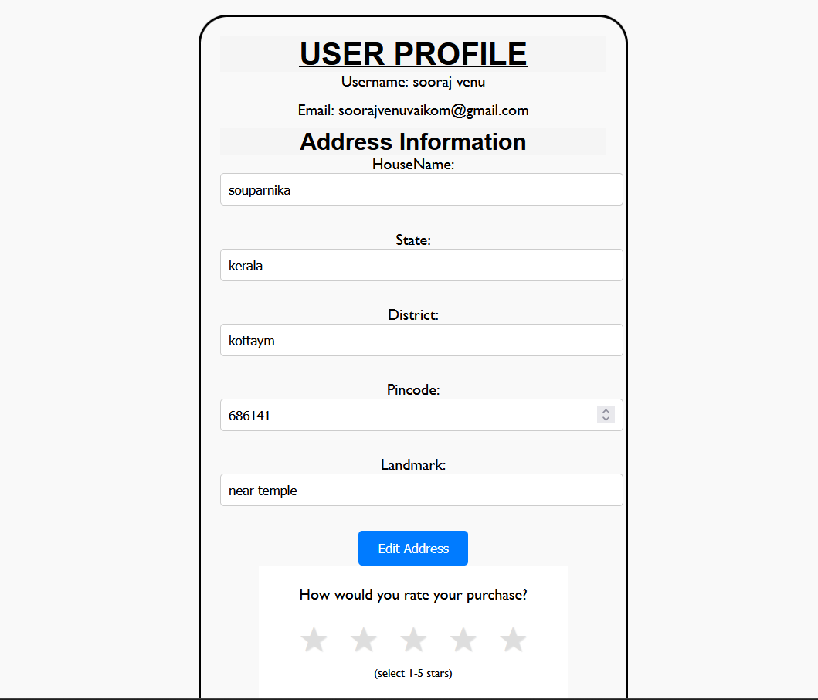**3.4.1 USER INTERFACE SCREEN DESIGN**

Fig 3.4.1 sample interface design

The above form is for the insertion of address values to the user profile details ,this address can be used for delivery purposes ,alternative address can be also used.

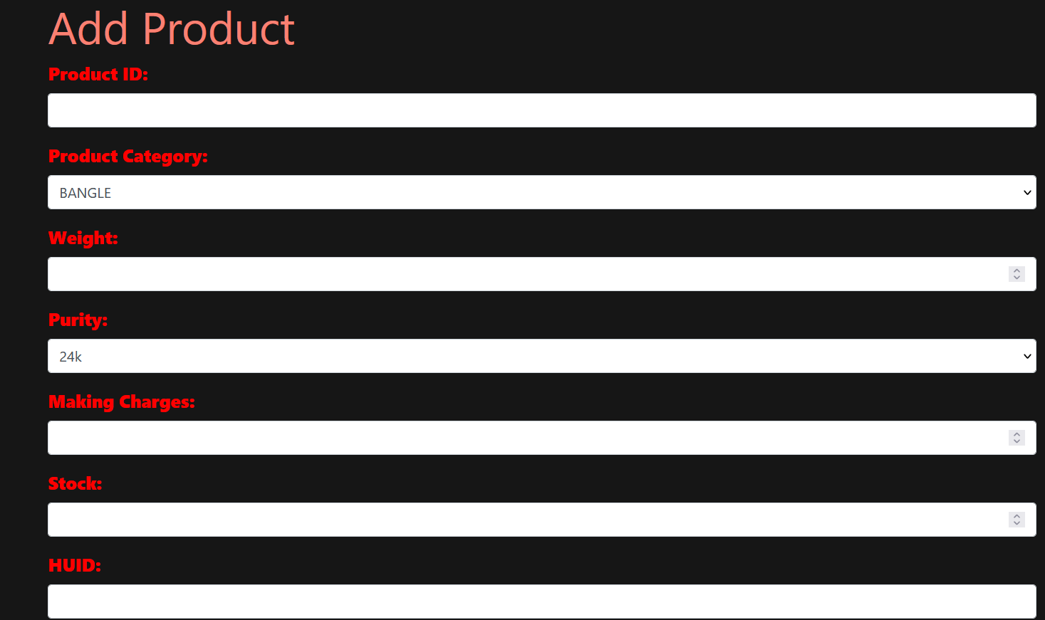

Fig 3.4.2 sample interface design

The above input form is in the Admin side and this is for the insertion of new gold product to the database the detailed values for the product to be Inserted should be given,the image adding provisions are also provided to the webpage

**3.4.2 OUTPUT DESIGN**

A quality output is one, which meets the requirements of end user and presents the information clearly. In any system result of processing are communicated to the user and to the other system through outputs. In the output design it is determined how the information is to be displayed for immediate need

It is the most important and direct source information is to the user. Efficient and intelligent output design improves the system’s relationships with the user and helps in decision -making. The objective of the output design is to convey the information of all the past activities, current status and to emphasis important events. The output generally refers to the results and information that is generated from the system. Outputs from computers are required primarily to communicate the results of processing to the Customers.

Two phases of the output design are:

1. Output Definition

2. Output Specification

Output Definition takes into account the type of output contents, its frequency and its volume, the appropriate output media is determined for output. Once the media is chosen, the detail specification of output documents are carried out

In our project the pie chart is developed for the sales report of the products,the values saled for each product categories are displayed

In our project the order details are also generated over a given dates and also over sorted by accepted, rejected, hold orders.

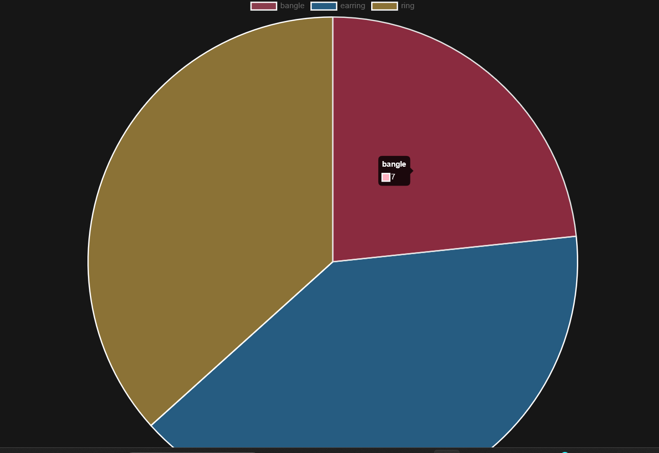Fig 3.4.2.1 pie chart-sales report

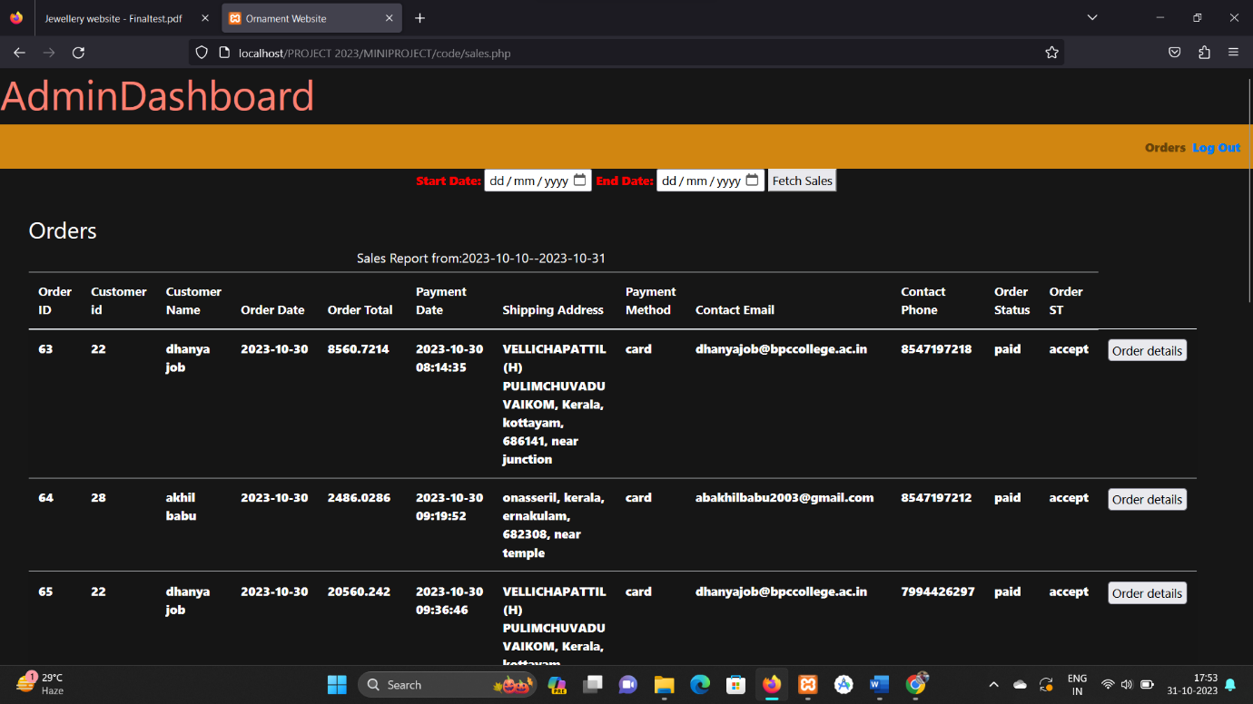

Fig 3.4.2.2 order details over a given dates

**4. IMPLEMENTATION**

Implementation is the stage of the project when the theoretical design is turned into a working system. The implementation stage is a systems project in its own rig ht. It includes careful planning, investigation of current system and its constraints on implementation, design of methods to achieve the changeover, training of the staff in the changeover procedure and evaluation of changeover method

**4.1. CODING STANDARDS**

Writing an efficient software code requires a thorough knowledge of programming. This knowledge can be implemented by following a coding style which comprises several guidelines that help in writing the software code efficiently and with minimum errors. These guidelines, known as coding guidelines, are used to implement individual programming language constructs, comments, formatting, and so on. These guidelines, if followed, help in preventing errors, controlling the complexity of the program, and increasing the readability and understandability of the program. A set of comprehensive coding guidelines encompasses all aspects of code development. To ensure that all developers work in a harmonized manner (the source code should reflect a harmonized style as a single developer had written the entire code in one session), the developers should be aware of the coding guidelines before starting a software project. Moreover, coding guidelines should state how to deal with the existing code when the software incorporates it or when maintenance is performed

**4.2. SAMPLE CODE**

<?php

session_start();

if (!isset($_SESSION['username'])) {

header("Location: loginpage.php");

exit();

}

$dbHost = "localhost";

$dbUser = "root";

$dbPass = "";

$dbName = "jewellery";

$conn = mysqli_connect($dbHost, $dbUser, $dbPass, $dbName);

if (!$conn) {

die("Database connection failed: " . mysqli_connect_error());

}

$userid=$_SESSION['userid'];

$sql6="SELECT * FROM tbl_cart where userid= '$userid'";

$result=mysqli_query($conn,$sql6);

if($result && mysqli_num_rows($result) > 0){

}else{

$sql="INSERT INTO tbl_cart values($userid,$userid)";

mysqli_query($conn,$sql);

}

if (isset($_GET['payment_success'])) {

$paymentSuccess = $_GET['payment_success'];

if ($paymentSuccess == 1) {

echo '<script>alert("Payment Successful check orders for further details");</script>';

} else {

echo '<script>alert("Payment Failed. Please try again.");</script>';

}

}

?>

<!DOCTYPE html>

<html lang="en">

<head>

<meta charset="UTF-8">

<meta name="viewport" content="width=device-width, initial-scale=1.0">

<title>Jewelley Store</title>

<link rel="stylesheet" href="styles.css"> <!-- Link your custom styles here -->

<style>

body, h1, h2, h3, ul, li {

margin: 0;

padding: 0;

background: black;

}

h1,h2,h3,p{

color:#913333;

}

/* Global styles */

body {

font-family: Arial, sans-serif;

font-weight: 800;

}

/* Header styles */

header {

background-color: #d26734;

color: #fff;

padding: 5px 0;

}

.nav-links {

list-style: none;

display: flex;

}

.nav-links li {

margin-right: 30px;

}

.nav-links a {

color: #fff;

text-decoration: none;

}

/* Hero section styles */

.hero {

background-image: url('hero-background.jpg');

background-size: cover;

background-position: center;

text-align: center;

color: ;

padding: 35px 0;

}

.hero h1 {

font-size: 36px;

margin-bottom: 20px;

}

.hero p {

font-size: 18px;

margin-bottom: 40px;

}

.cta-button {

display: inline-block;

background-color: #b47d2d;

color: #fff;

padding: 10px 20px;

border-radius: 5px;

text-decoration: none;

font-weight: bold;

}

.cta-button:hover {

background-color: #a66a25;

}

/* Featured products section styles */

.featured-products {

padding: 50px 0;

text-align: center;

}

.featured-products h2 {

font-size: 24px;

margin-bottom: 20px;

}

.product-list {

display: flex;

justify-content: center;

}

.product {

margin: 0 20px;

}

.product img {

max-width: 100%;

border-radius: 5px;

padding: 10px;

}

img{

max-width: 100%;

border-radius: 30px;

padding: 10px;

}

.product h3 {

font-size: 20px;

margin-top: 10px;

}

.product p {

font-size: 16px;

color: #555;

}

/* Footer styles */

footer {

background-color: #7e4c34;

color: #fff;

text-align: center;

padding: 15px 0;

}

.welcome-user {

margin-left: auto;

}

</style>

<script src="https://code.jquery.com/jquery-3.6.0.min.js"></script>

</head>

<body>

<header>

<nav>

<div class="logo">

<center>

<a href="dashboard.php"><img src="IMG/SITEIMG/logo1.png" height="100" width="180">

</a>

</center>

</div>

<ul class="nav-links">

<li><a href="dashboard.php">Home</a></li>

<li><a href="display.php">Shop</a></li>

<li><a href="collections.php">Collections</a></li>

<li><a href="cart.php">Cart</a></li>

<li><a href="userorder.php">Orders</a></li>

<li><a href="aboutusdis.php">About Us</a></li>

<li class="welcome-user">

<div >

<a href="profile.php">

<?php

if (isset($_SESSION['username'])) {

echo '<span id="user-profile-toggle">Welcome, . strtoupper($_SESSION['username']) . '!</span>';

}

?></a>

</div>

</li>

<li>

<?php

// Assuming you have a database connection established

// Fetch gold rate from tbl_goldproduct

$sqlGold = "SELECT rate FROM tbl_goldproduct WHERE productid = 'G100'"; // Adjust the WHERE condition as needed

$resultGold = mysqli_query($conn, $sqlGold);

$goldRate = mysqli_fetch_assoc($resultGold)['rate'];

// Fetch silver rate from tbl_silverproduct

$sqlSilver = "SELECT rate FROM tbl_silverproduct WHERE productid = 'S100'"; // Adjust the WHERE condition as needed

$resultSilver = mysqli_query($conn, $sqlSilver);

$silverRate = mysqli_fetch_assoc($resultSilver)['rate'];

echo "Gold Rate: $" . number_format($goldRate, 2); // Format as needed

echo " - | - ";

echo "Silver Rate: $" . number_format($silverRate, 2); // Format as needed

?>

</li>

<li>

<?php

if (isset($_SESSION['username'])) {

echo '<a href="logout.php">Logout</a>';

} else {

echo '<a href="loginpage.php">Login</a>';

}

?>

</li>

</ul>

</nav>

</header>

<section class="hero">

<a href="display.php"><img src="IMG/SITEIMG/fs6.png" height="425" width="1500"></a>

</section>

<section class="hero">

<div class="hero-content">

<h1>Welcome to Our Jewellery Store</h1>

<a href="display.php" class="cta-button">Shop Now</a>

</div>

</section>

<section class="hero">

<p>Discover exquisite jewelley pieces that dazzle and inspire.</p>

<img src="IMG/SITEIMG/designedfor.png" >

</section>

<img src="IMG/SITEIMG/fs5.png">

<section class="hero">

</section>

<header>

<img src="IMG/SITEIMG/fs4.png" width="1500" align="center">

</header>

<section class="featured-products">

<h2>Featured Products</h2>

<div class="product-list">

<div class="product">

<a href="display.php"> <img src="IMG/SITEIMG/er3.png" alt="Product 1" height="350" width="350"></a>

<h3>Sparkling Gold Earrings</h3>

<p>Perfect for any occasion</p>

</div>

<div class="product">

<a href="display.php"><img src="IMG/SITEIMG/CHAINSITE.png" alt="Product 2" height="350" width="350"></a>

<h3>Gold Chain Necklace</h3>

<p>Elegance and style combined</p>

</div>

<div class="product">

<a href="display.php"><img src="IMG/SITEIMG/bangle11.png" alt="Product 3" height="350" width="350"></a>

<h3>Gold Bracelet</h3>

<p>Minimalist design for everyday wear</p>

</div>

</div>

</section>

<footer>

<?php

$sql = "SELECT * FROM tbl_aboutus";

$result = $conn->query($sql);

// Fetch and display the data

if ($result->num_rows > 0) {

while ($row = $result->fetch_assoc()) {

echo "<footer>";

echo "<h3>" . $row['description_au'] . "</h3>";

// Add more elements as needed

echo "</footer>";

}

} else {

echo "No data found in tbl_aboutus";

}?>

</footer>

</body>

</html>

**5. TESTING**

Coding conventions are a set of guidelines for a specific programming language that recommend programming style, practices and methods for each aspect of a piece program written in this language. These conventions usually cover file organization, indentation, comments, declarations, statements, white space, naming conventions, programming practices, programming principles, programming rules of thumb, architectural best practices, etc. These are guidelines for software structural quality. Software programmers are highly recommended to follow these guidelines to help improve the readability of their source code and make software maintenance easier

**5.1 TEST CASES**

The objective of system testing is to ensure that all individual programs are working as expected, that the programs link together to meet the requirements specified and to ensure that the computer system and the associated clerical and other procedures work together. The initial phase of system testing is the responsibility of the analyst who determines what conditions are to be tested, generates test data, produced a schedule of expected results, runs the tests and compares the computer produced results with the expected results with the expected results. The analyst may also be involved in procedures testing. When the analyst is satisfied that the system is working properly, he hands it over to the Customers for testing. The importance of system testing by the user must be stressed. Ultimately it is the user must verify the system and give the go-ahead.

During testing, the system is used experimentally to ensure that the software does not fail, i.e., that it will run according to its specifications and in the way Customers expect it to. Special test data is input for processing (test plan) and the results are examined to locate unexpected results. A limited number of Customers may also be allowed to use the system so analysts can see whether they try to use it in unexpected ways

Testing is the process of correcting a program with intends of finding an error. Different types

of testing are,

1. Unit Testing

2. Integrated Testing

3. Black Box Testing

4. White Box Testing

5. Validation Testing

6. User Acceptance Testing

**5.1.1 UNIT TESTING**

In computer programming, unit testing is a method by which individual units of source code, sets of one or more computer program modules together with associated control data, usage procedures, and operating procedures are tested to determine if they are fit for use In this testing we test each module individual and integrated the overall system. Unit testing focuses verification efforts on the smaller unit of software design in the module. This is also known as module testing. . In this testing step each module is found to working satisfactory as regard to the expected output from the module. There are some validation checks for verifying the data input given by the user which both the formal and validity of the 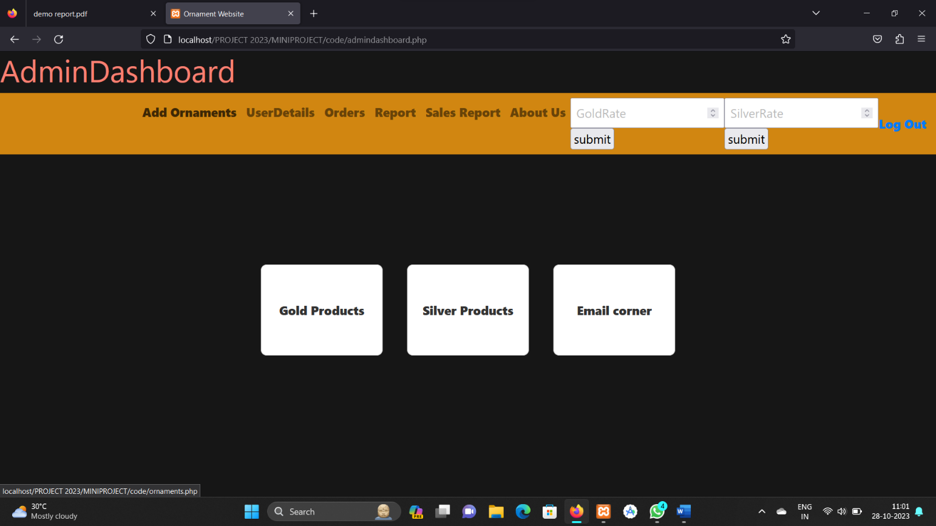entered. It is very easy to find error debug the system.

Fig 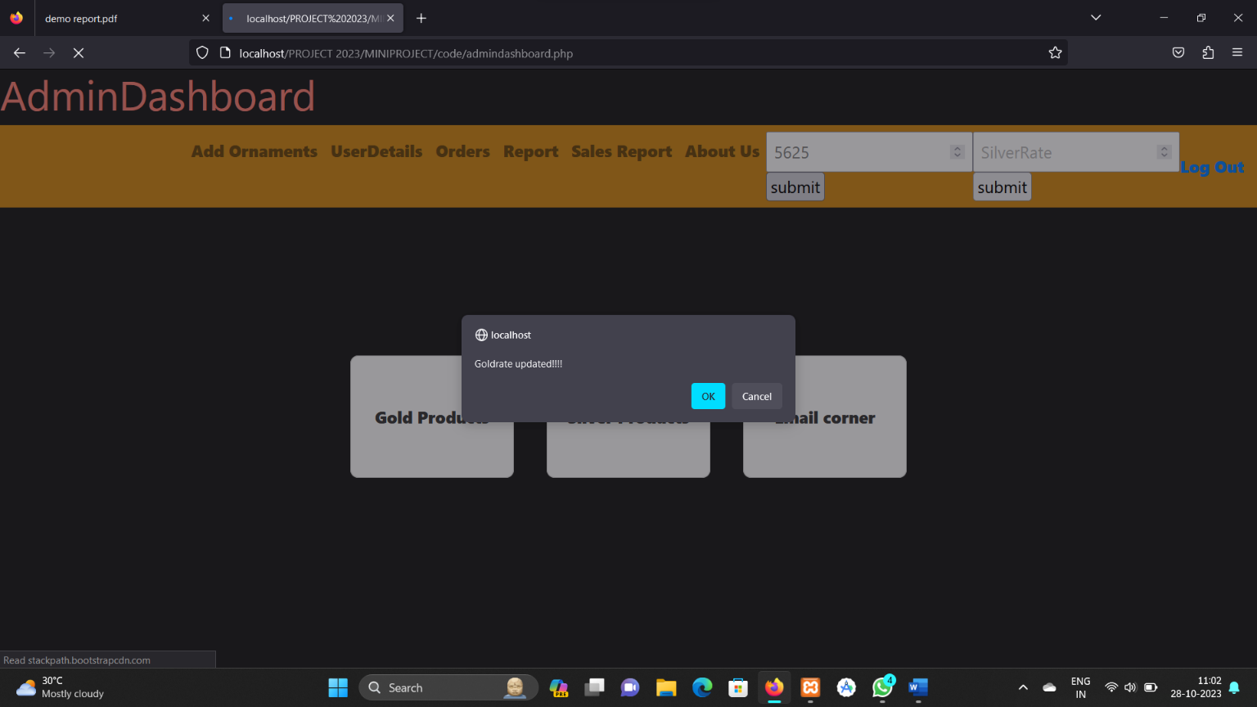5.1 Unit testing

Fig 5.2 Unit testing result

**5.1.2 Integration Testing**

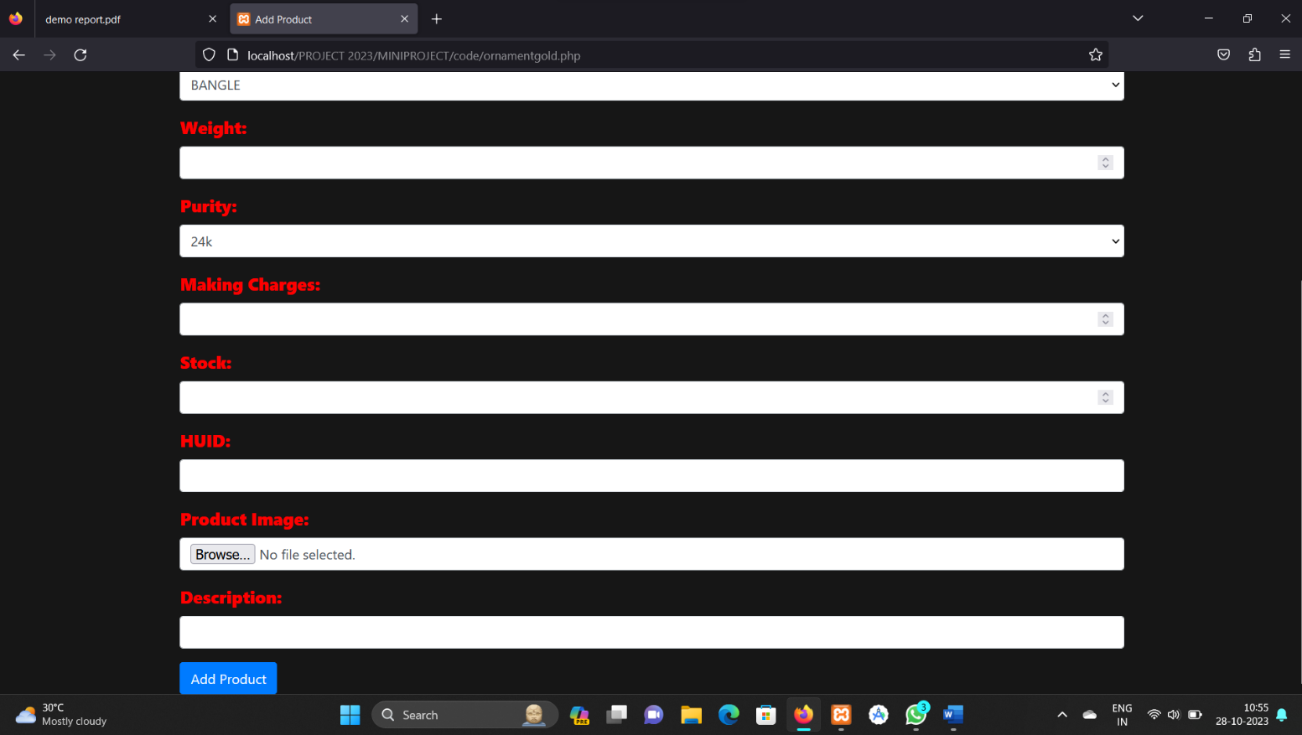Integration testing (sometimes called integration and testing, abbreviated I&T) is the phase in software testing in which individual software modules are combined and tested as a group. Software components may be integrated in an iterative way or all together ("big bang"). Normally the former is considered a better practice since it allows interface issues to be located more quickly and fixed. Data can be lost across an interface; one module can have an adverse effort on the other sub functions when combined by, may not produce the desired major functions. Integrated testing is the systematic testing for constructing the uncover errors within the interface. This testing was done with sample data. The developed system has run success full for this sample data. The need for integrated test is to find the overall system performance.

Fig 5.3 Integration Testing

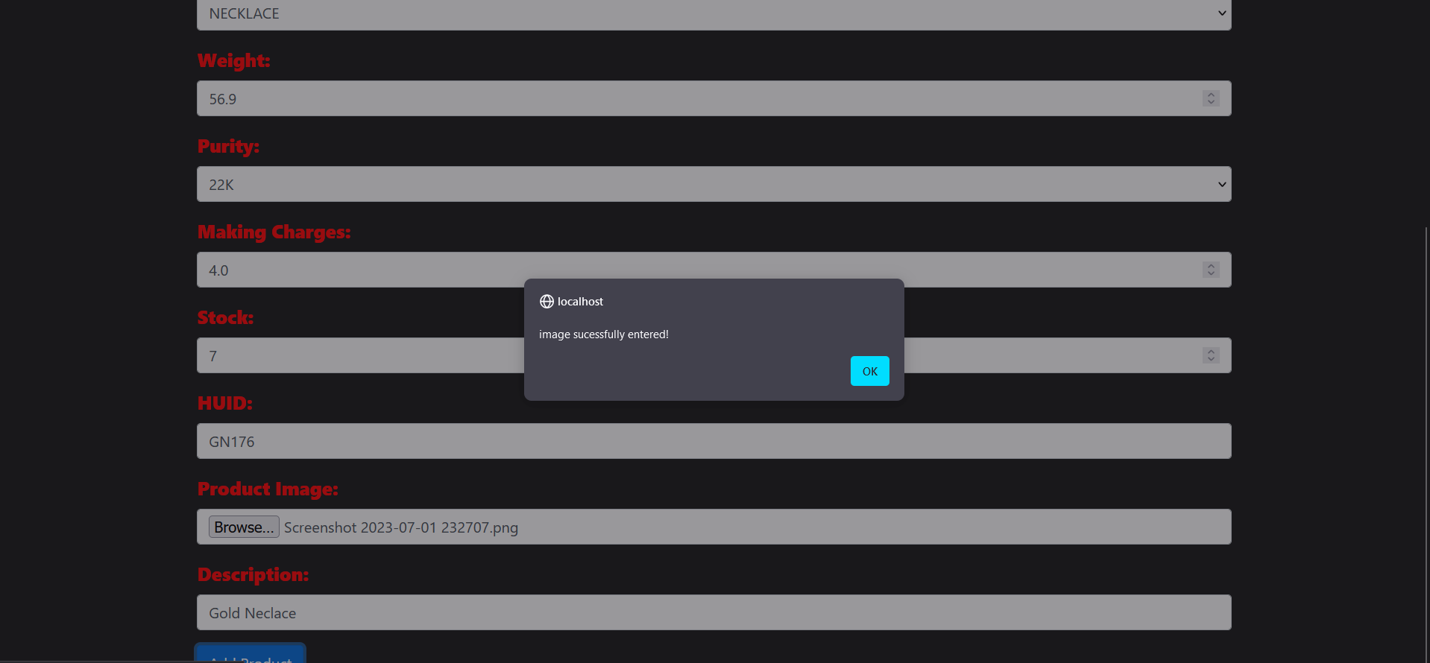

Fig 5.4 Integration Testing Result

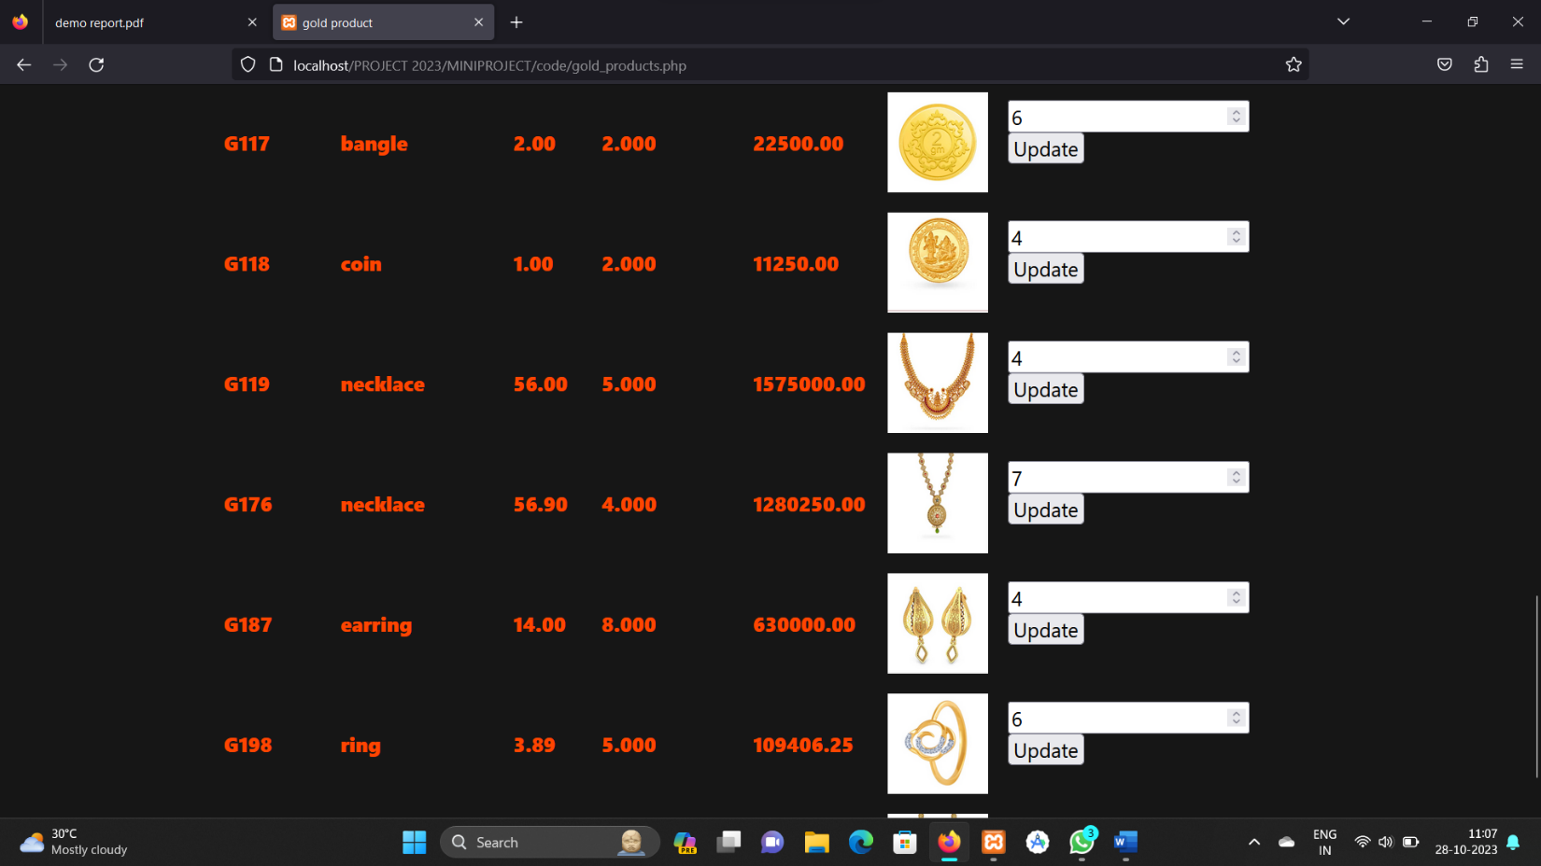

Fig 5.5 Integration testing Result

**5.1.3. Black Box Testing**

Black-box testing is a method of software testing that examines the functionality of an application (e.g. what the software does) without peering into its internal structures or workings. This method of test can be applied to virtually every level of software testing: unit, integration, system and acceptance. It typically comprises most if not all higher level testing, but can also dominate unit testing as well. In black box testing the structure of the program is not considered. Test cases are decided solely on the basis of the requirements or the specification of the program or module, and the internals of the module or program are not considered for selection of the test cases.

**5.1.4. White Box Testing**

White-box testing (also known as clear box testing, glass box testing, and transparent box testing and structural testing) is a method of testing software that tests internal structures or workings of an application, as opposed to its functionality. In white-box testing an internal perspective of the system, as well as programming skills, are used to design test cases. The tester chooses inputs to exercise paths through the code and determine the appropriate output. This is analogous to testing nodes in a circuit, e.g. in-circuit testing (ICT).While white-box testing can be applied at the unit, integration and system levels of the software testing process, it is usually done at the unit level. It can test paths within a unit ,paths between units during integration, and between subsystems during a system–level test. Though this method of test design can uncover many errors or problems, it might not detect unimplemented parts of the specification or missing requirements. White Box testing is concerned with testing the implementation of the program.

**5.1.5. Validation Testing**

At the culmination of Black Box testing, software is completely assembled as a package, interface errors have been uncovered and corrected and final series of software tests, Validation tests begins. Validation testing can be defined many was but a simple definition is that validation succeeds when the software functions in a manner that can be reasonably accepted by the customer. After validation test has been conducted one of the two possible conditions exists

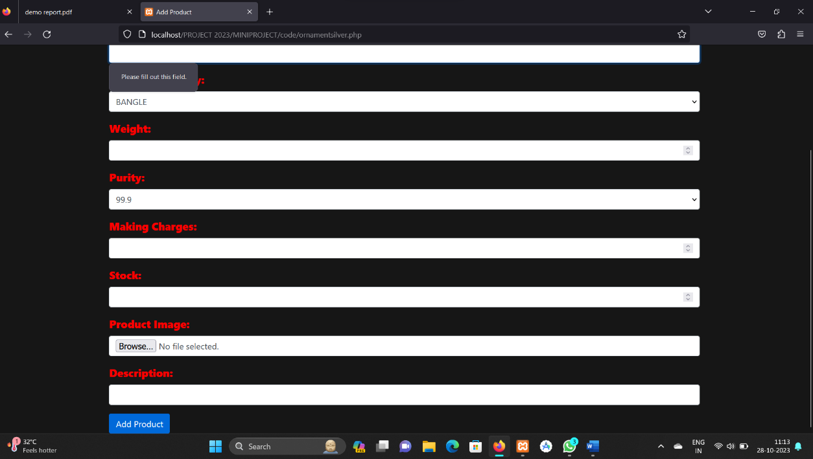

Fig 5.6 Ornament insertion

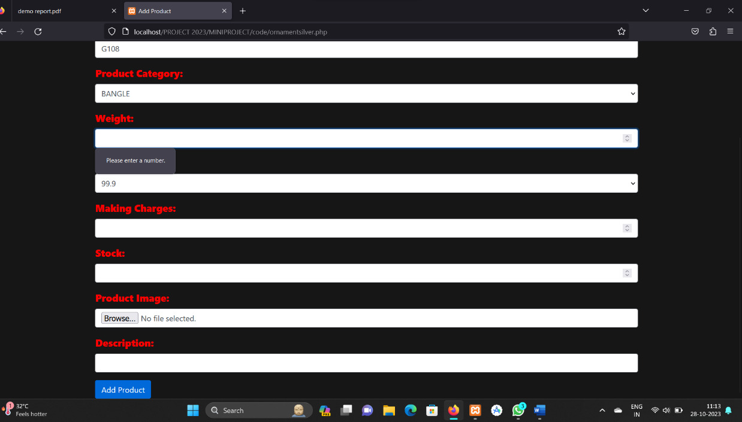

Fig5.7 Ornament insertion validation

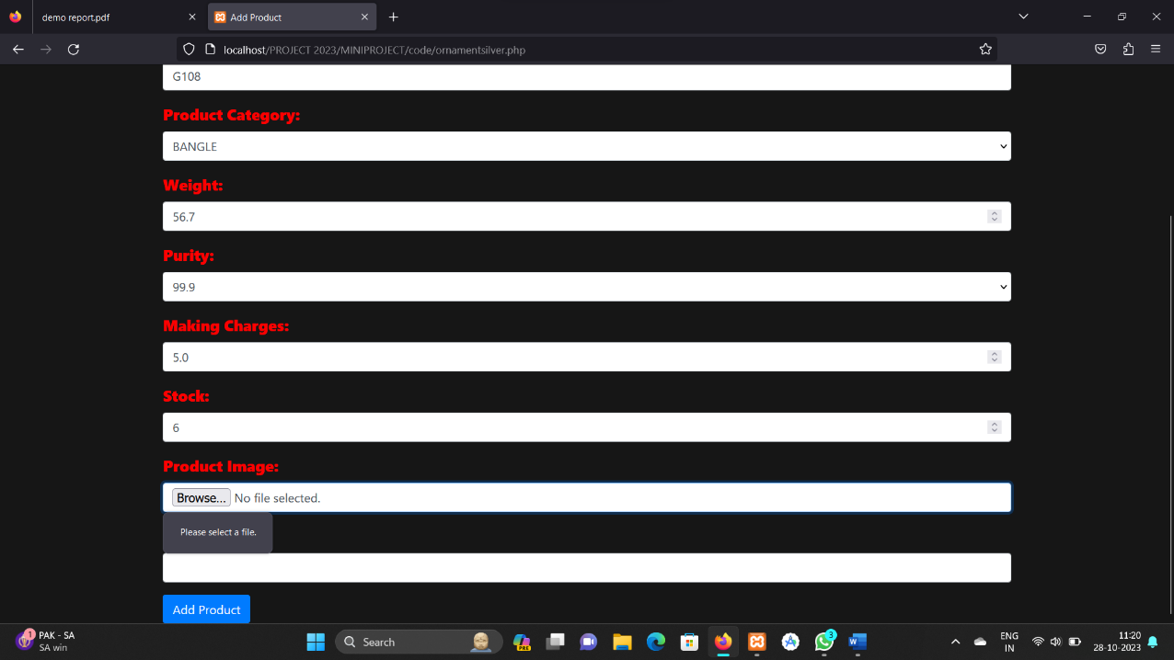

Fig 5.8 Product Image validation

Fig 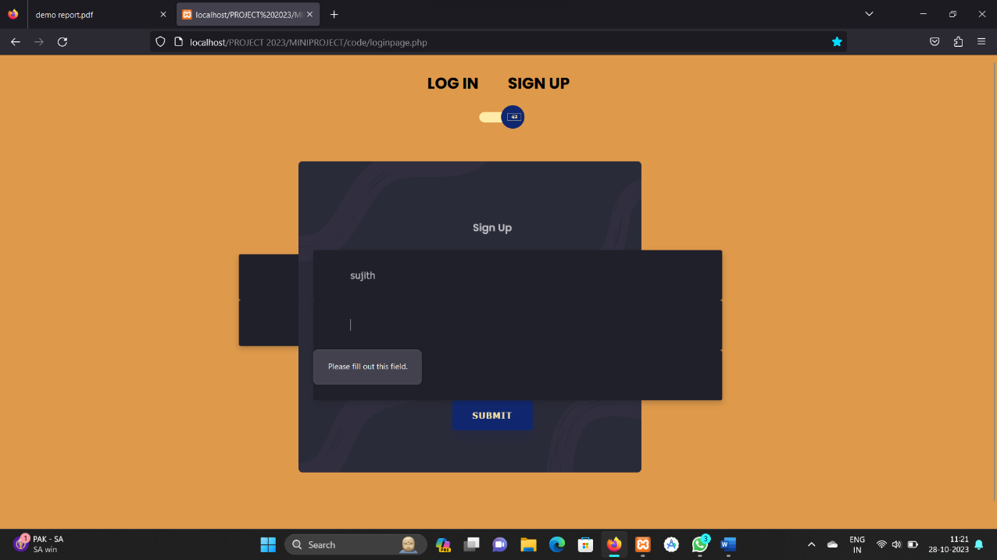5.9 Login validation

Fig 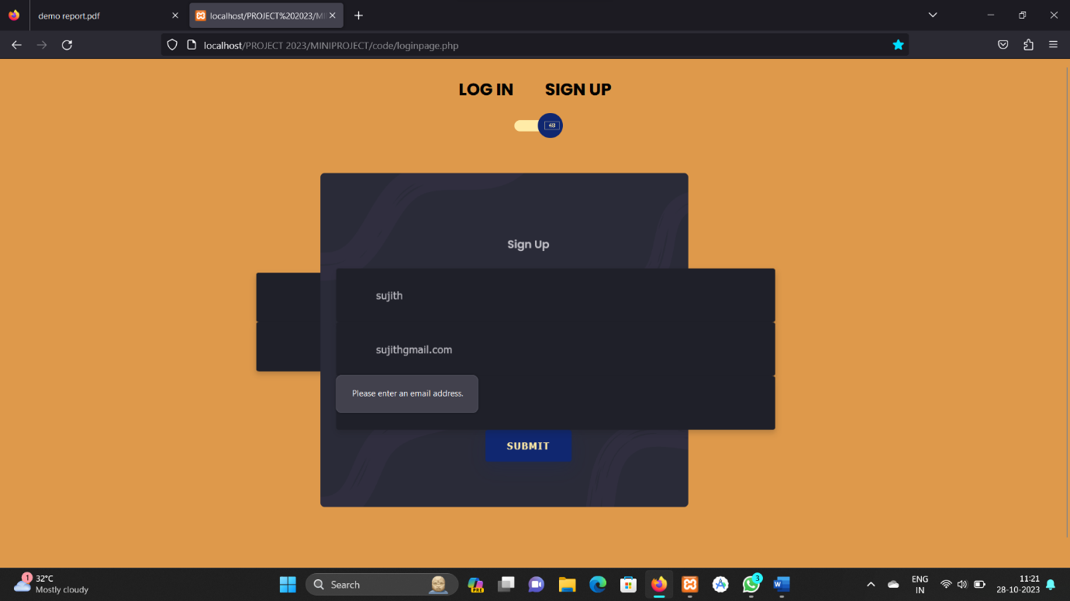5.10 Email validation

Fig 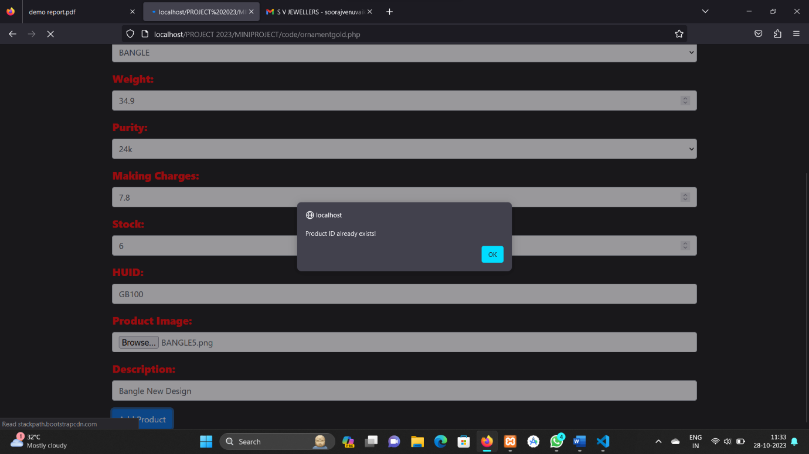5.11 Product Id already exist validation

We have given various validations in our forms so that there will be a neat format for the data’s that are entered on to the website. We have also given an already existing validation so that the data redundancy is reduced; same data is not entered twice

**5.1.6. USER ACCEPTANCE TESTING**

Acceptance Testing is a level of the software testing process where a system is tested for acceptability. User Acceptance testing is the software testing process where system tested for acceptability & validates the end to end business flow. Such type of testing executed by client in separate environment & confirms whether system meets the requirements as per requirement specification or not. UAT is performed after System Testing is done and all or most of the major defects have been fixed. This testing is to be conducted in the final stage of Software Development Life Cycle (SDLC) prior to system being delivered to a live environment. UAT Customers or Customers are concentrating on end to end scenarios & typically involves running a suite of tests on the completed system

User Acceptance testing also known as Customer Acceptance testing (CAT), if the system is being built or developed by an external supplier. The CAT or UAT are the final confirmation from the client before the system is ready for production. The business customers are the primary owners of these UAT tests. These tests are created by business customers and articulated in business domain languages. So ideally it is collaboration between business customers, business analysts, testers and developers. It consists of test suites which involve multiple test cases & each test case contains input data (if required) as well as the expected output. The result of test case is either a pass or fail.

**5.2 TEST CASE DOCUMENTS**

|  |  |  |  |  |  |
| --- | --- | --- | --- | --- | --- |
| SI NO | Test Steps | Expected Result | Actual Result | Status | Comment |
| 1 | Run application to Login Page | Login Screen is displayed ,username and password should be entered and click submit button | Login screen displayed and username, password should be entered | PASS |  |
| 2 | Enter an invalid username and password | Invalid username and password alert should popup | Popup alert is displayed on screen | PASS |  |
| 3 | Enter a valid username and password | Should redirect the page to main dashboard | Redirected to main dashboard page | PASS |  |
| 4 | Enter username and leave password unentered | Error should be displayed | “password required” message will be printed | PASS |  |
| 5 | Enter a valid  username and  invalid password  and press the  button | Should give alert that password is wrong | Invalid username and password will be alerted | PASS |  |

5.2.1 example Test cases

A test case is a set of conditions or variables under which a tester will determine whether a system under test satisfies requirements or works correctly.

The process of developing test cases can also help find problems in the requirements or design o an application. A sample of test case document format is given above.

**6.CONCLUSION**

The project was successfully completed within the time span allotted. All the modules are tested separately and put together to form the main system. Finally, the modules are tested with real data and it worked successfully. Thus the system has fulfilled the entire objective defined .

In conclusion, SV Jewellers is your gateway to a world of timeless elegance and exquisite craftsmanship. Our website is more than just an online store; it's a journey through the beauty of fine jewellery and a testament to our commitment to quality and customer satisfaction. With a wide range of stunning jewellery pieces, personalized options, and a dedication to ethical practices, SV Jewellers is here to make every moment special.

We invite you to explore our collections, experience the luxury of our pieces, and trust us with your most cherished moments. Whether you're looking for the perfect engagement ring, a meaningful gift, or an accessory to enhance your personal style, SV Jewellers has something to offer. We hope that your visit to our website has been a delightful and informative experience.

Beyond the aesthetics, we are deeply committed to ethical practices, ensuring that the journey from the source to your hands is as transparent and responsible as possible. We believe in not just creating beautiful jewellery, but in making a positive impact on the world

**6.1. FUTURE ENHANCEMENTS**

Enhancing a jewellery website in the future can involve various strategies and improvements to make it more appealing, user-friendly, and competitive. Here are some potential enhancements you can consider:

• **Mobile Optimization:** Ensure that your website is fully responsive and functions seamlessly on various mobile devices. Mobile optimization is crucial as more Customers are accessing websites from their smartphones.

• **High-Quality Imagery:** Jewellery is a visual product, and high-resolution images are essential. Consider 360-degree views or zoom features to allow customers to inspect the jewellery closely.

• **User-Friendly Navigation:** Make sure your website is easy to navigate. Use clear categories and filters to help customers find the jewellery they're looking for quickly.

• **Search Functionality:** Implement a robust search feature that can handle misspellings and synonyms to help Customers find products more easily.

• **Product Descriptions:** Provide detailed and informative product descriptions, I ncluding material, size, weight, and care instructions.

• **Customer Reviews:** Allow customers to leave reviews and ratings for products. Honest reviews can build trust and help others make informed decisions.

• **Virtual Try-On:** Consider integrating technology that allows customers to virtually try on jewellery. Augmented reality (AR) can be a powerful tool in the jewellery industry.

7.APPENDIX

**7.1 SCREENSHOTS**

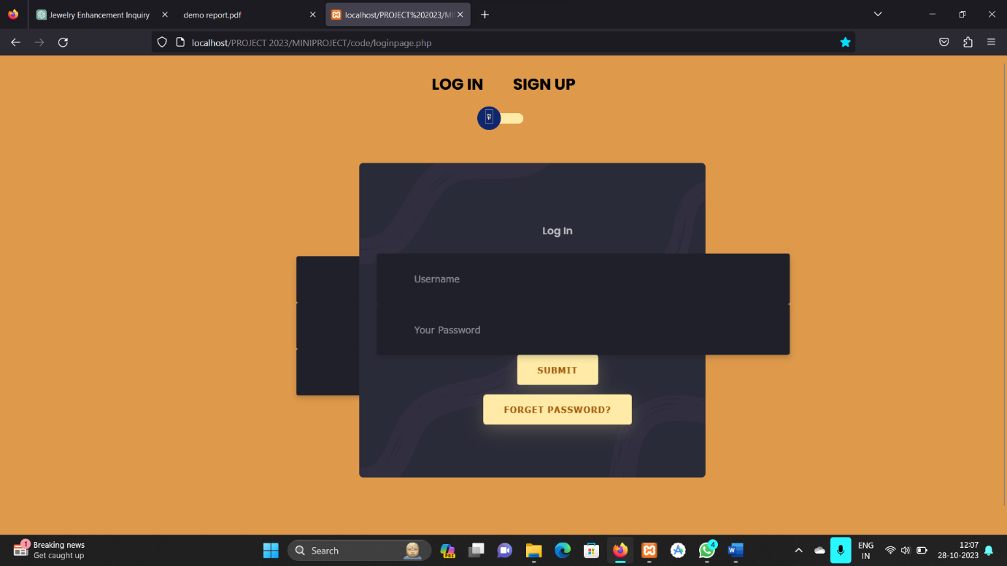

Fig 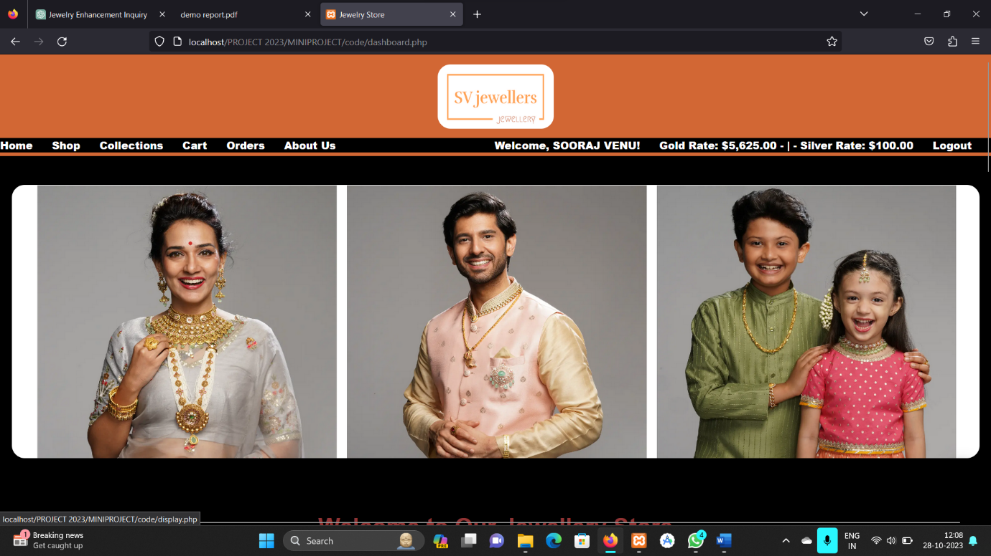7.1.1 Login page-SV jewellers

Fig 7.1.2 Dashboard user side

Fig 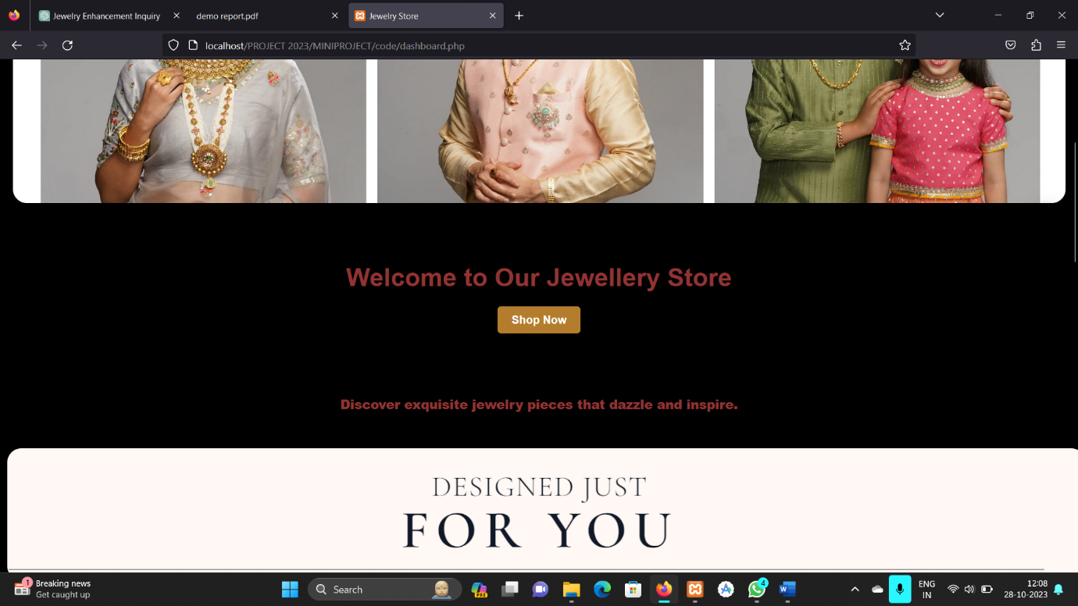7.1.3 Dashboard-user part

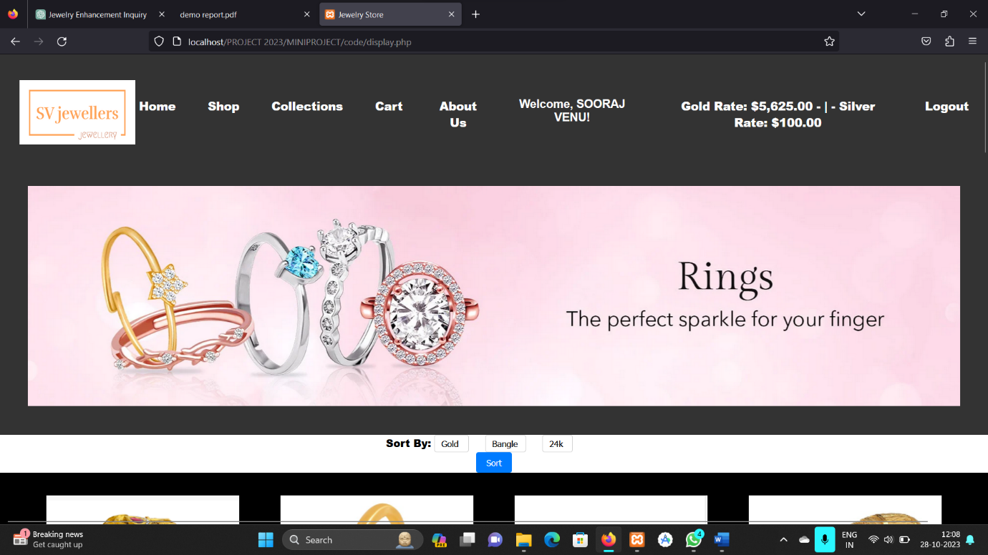

Fig 7.1.4 Shop page-SV jewellers

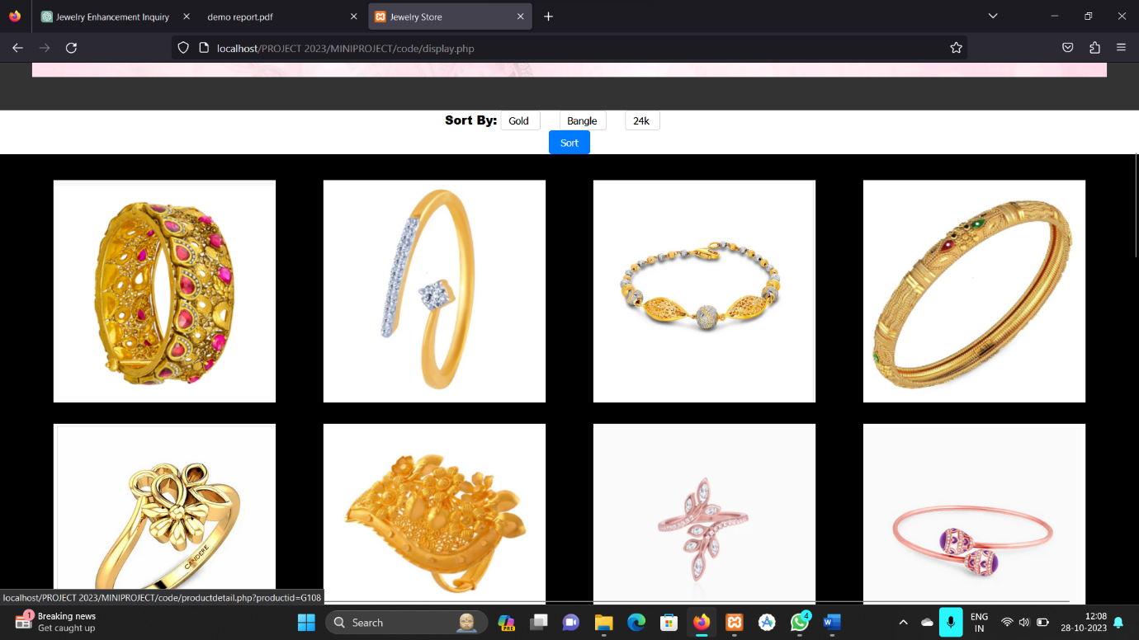

Fig 7.1.5 Shop-Product listings

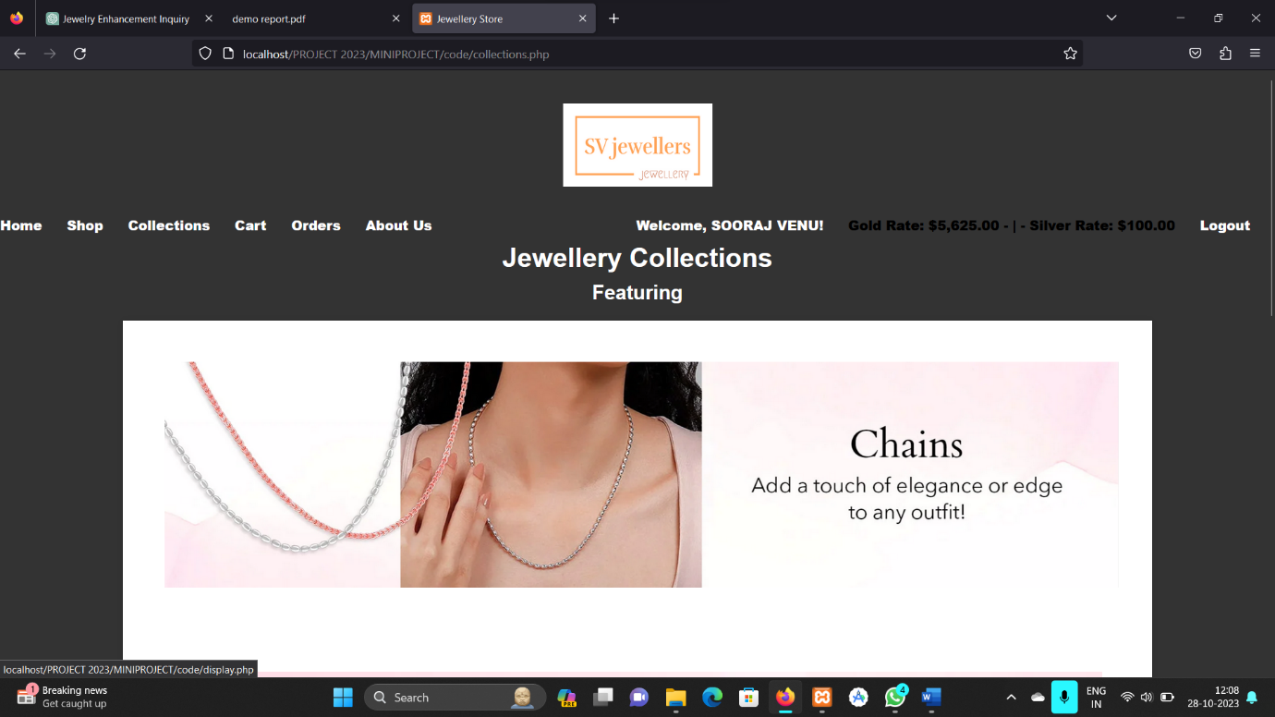

Fig 7.1.6 Collections page

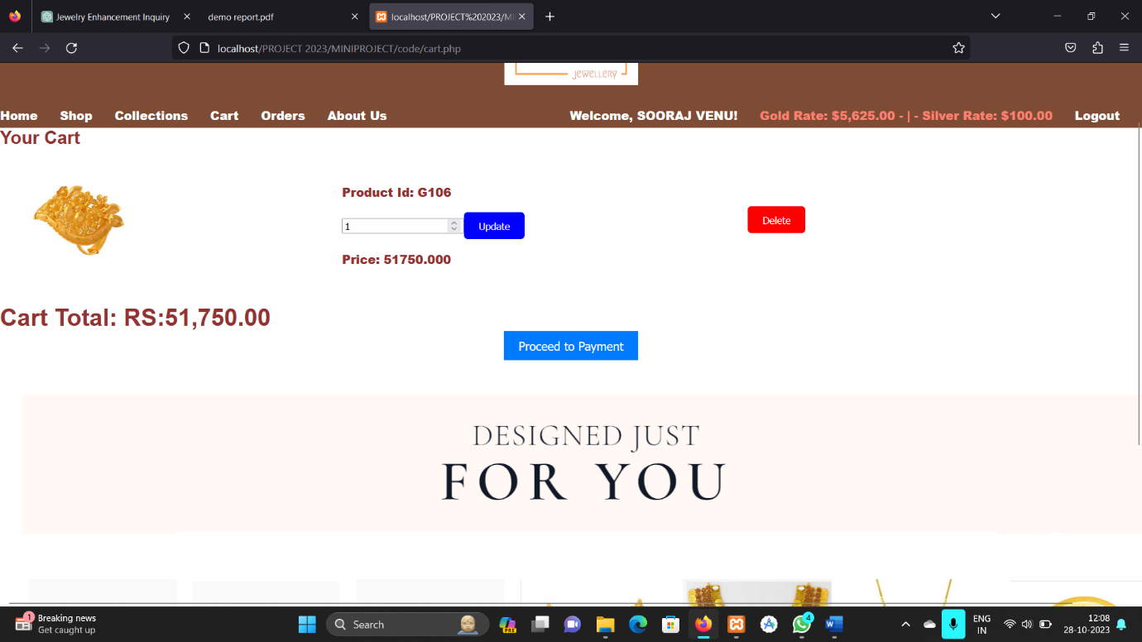

Fig 7.1.7 Cart page-SV jewellers

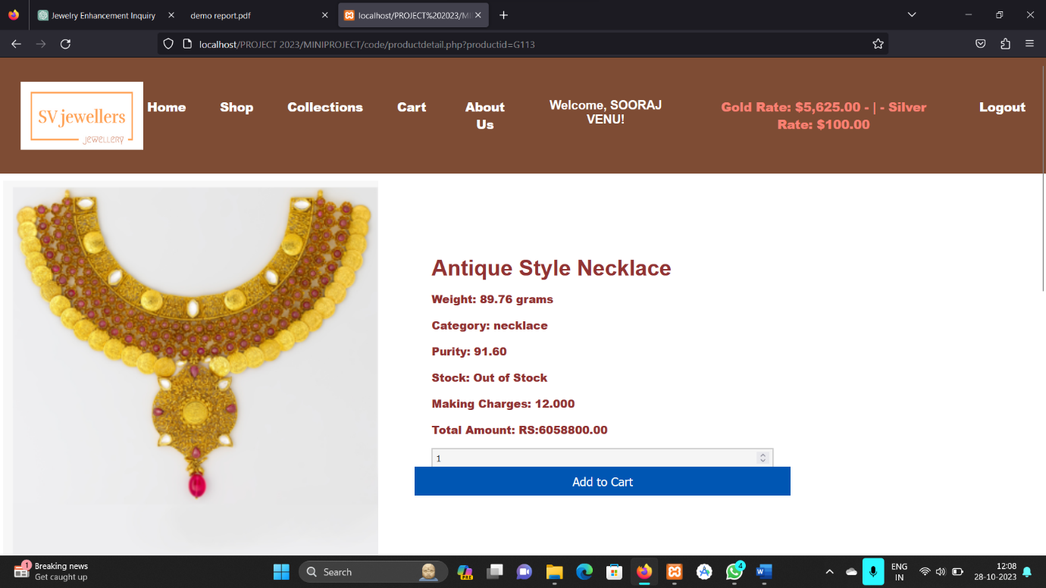

Fig 7.1.8 Product details

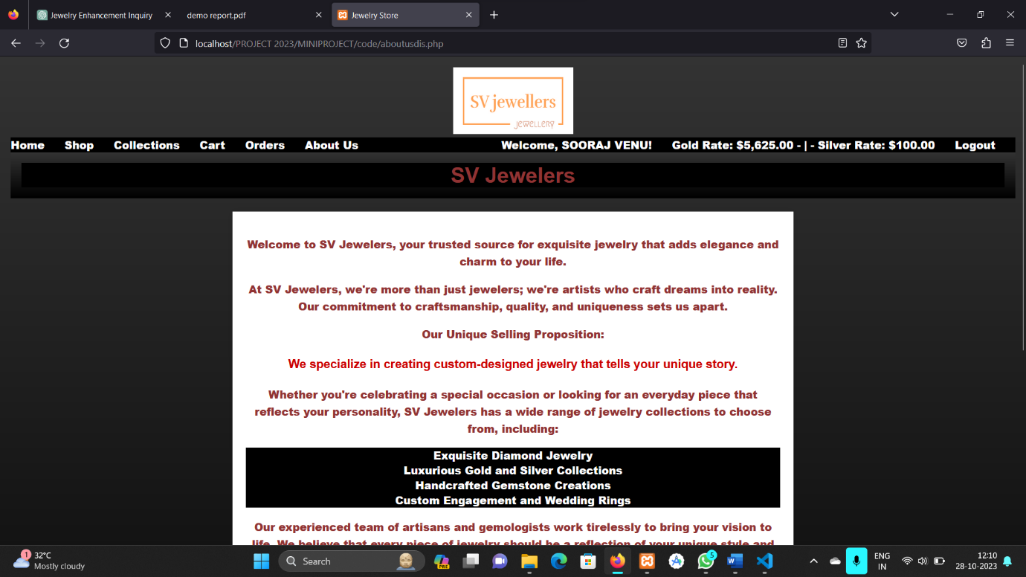

Fig 7.1.9 SV Jewellers about us page

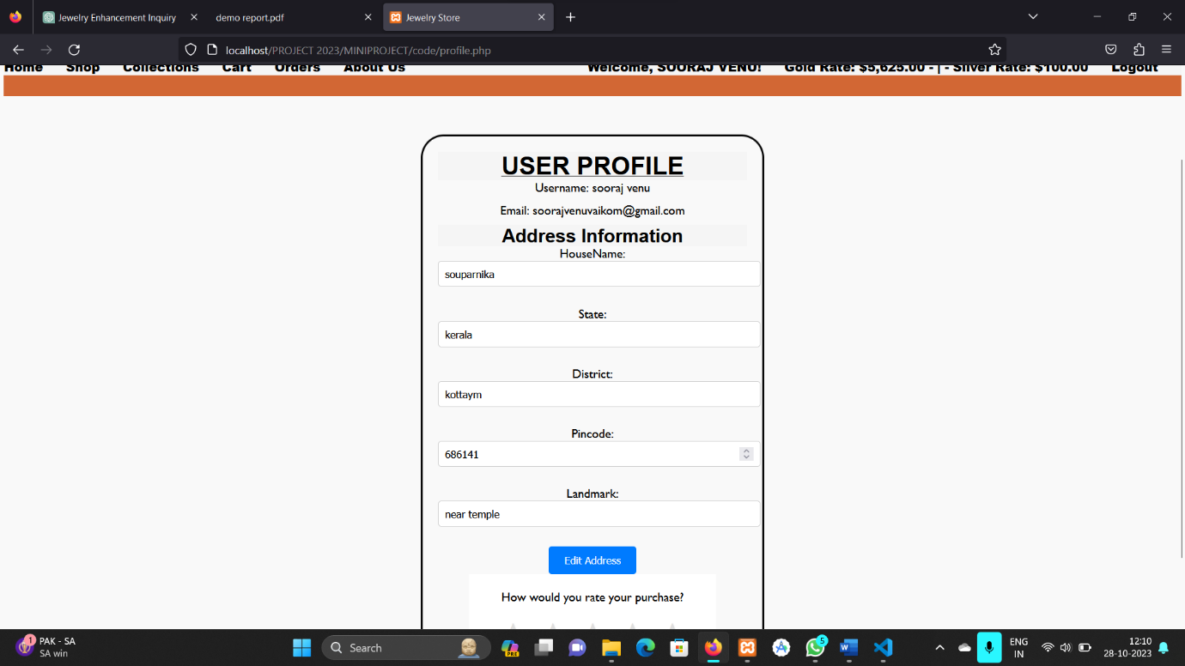

Fig 7.1.10 User Profile

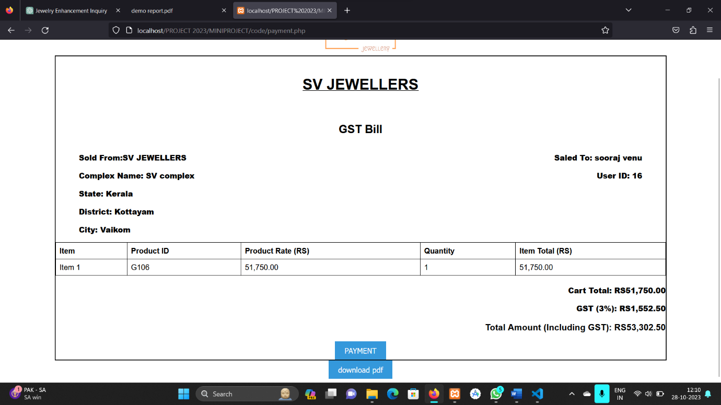

Fig 7.1.11 GST Bill Generated

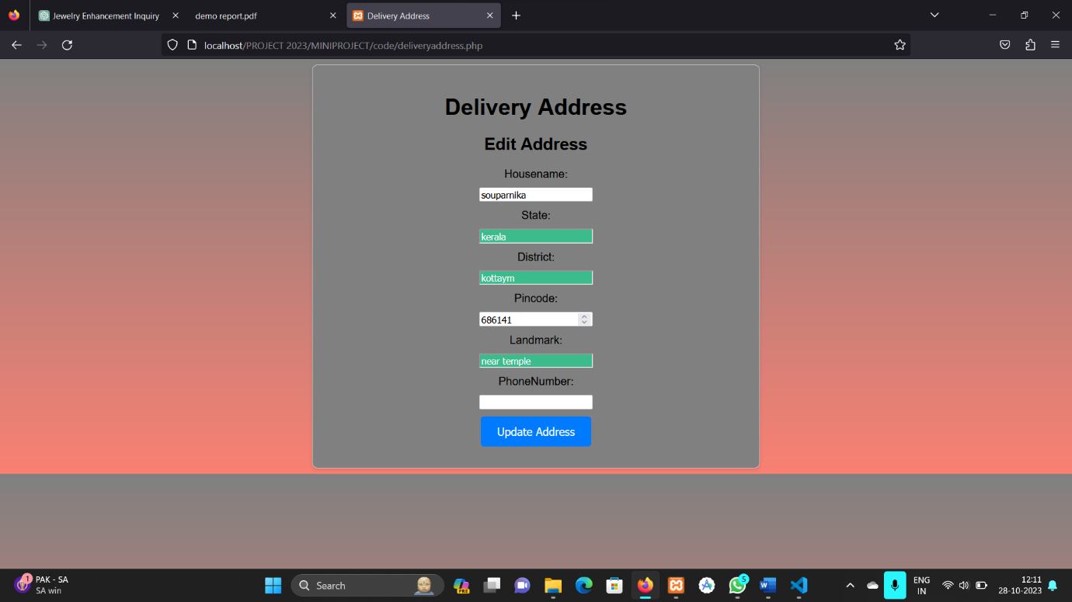

Fig 7.1.12 Delivery Address

Fig 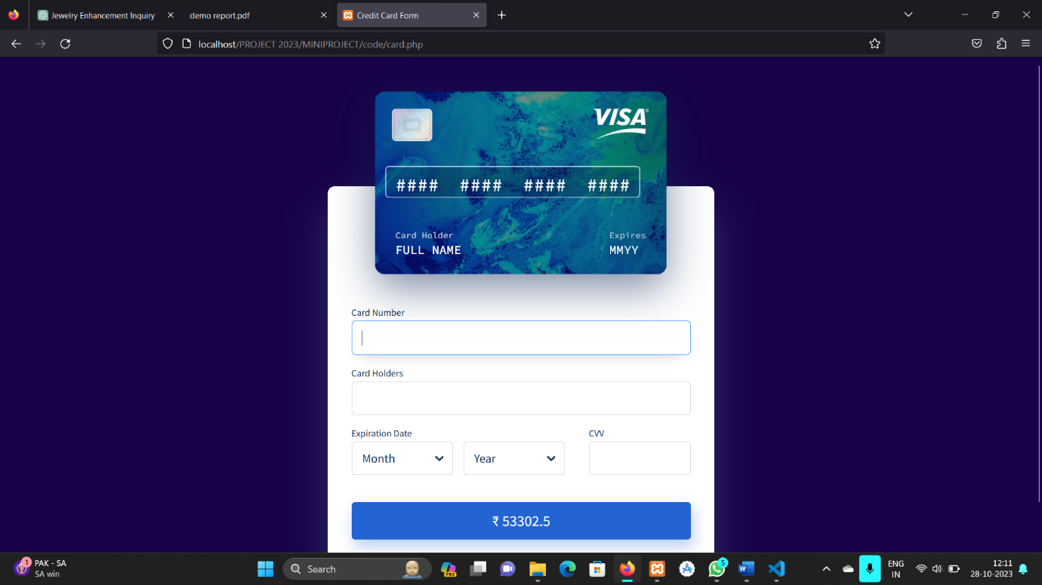7.1.13 Card Payment

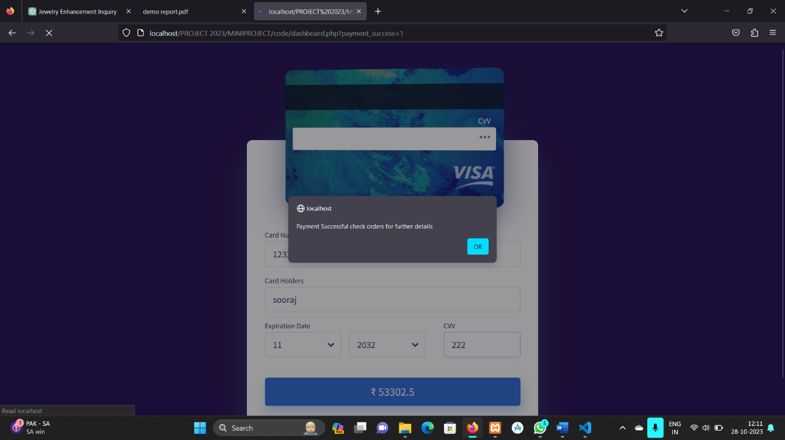

Fig 7.1.13 Payment Successful alert

Fig 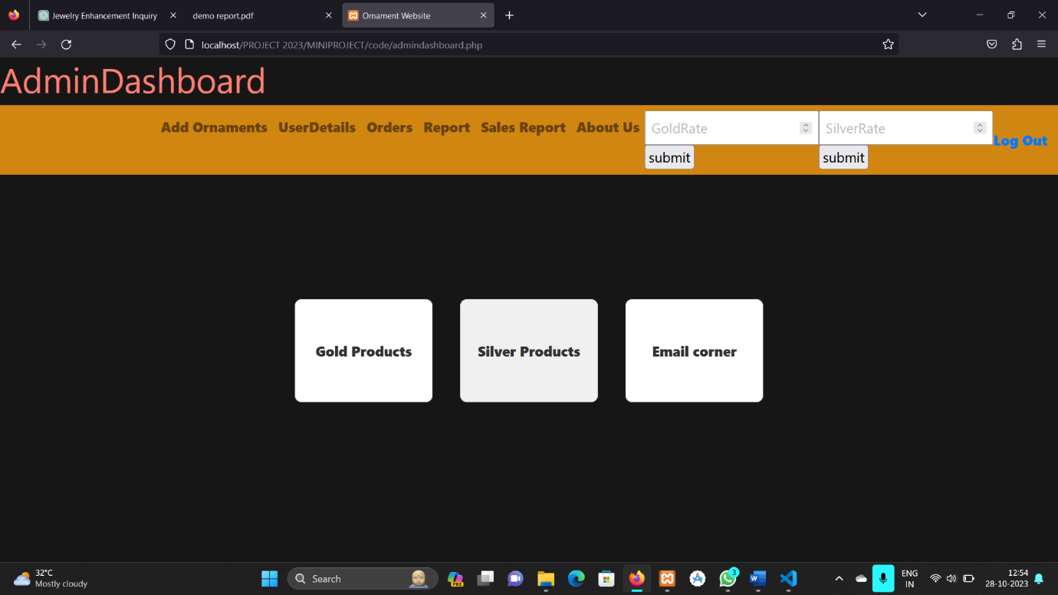7.1.14 Admin Dashboard

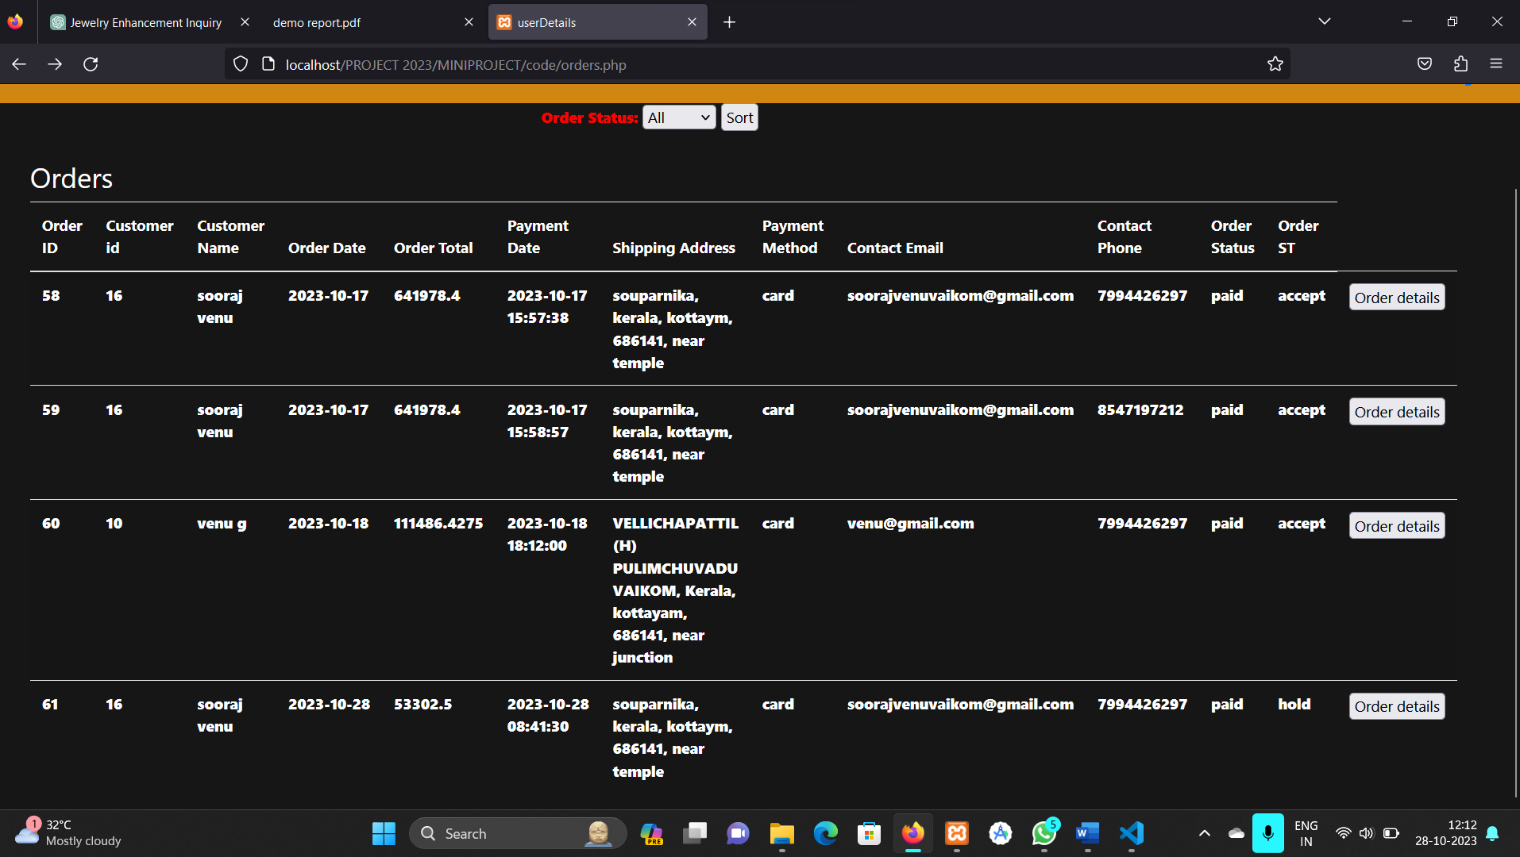

Fig 7.1.15 Orders listed

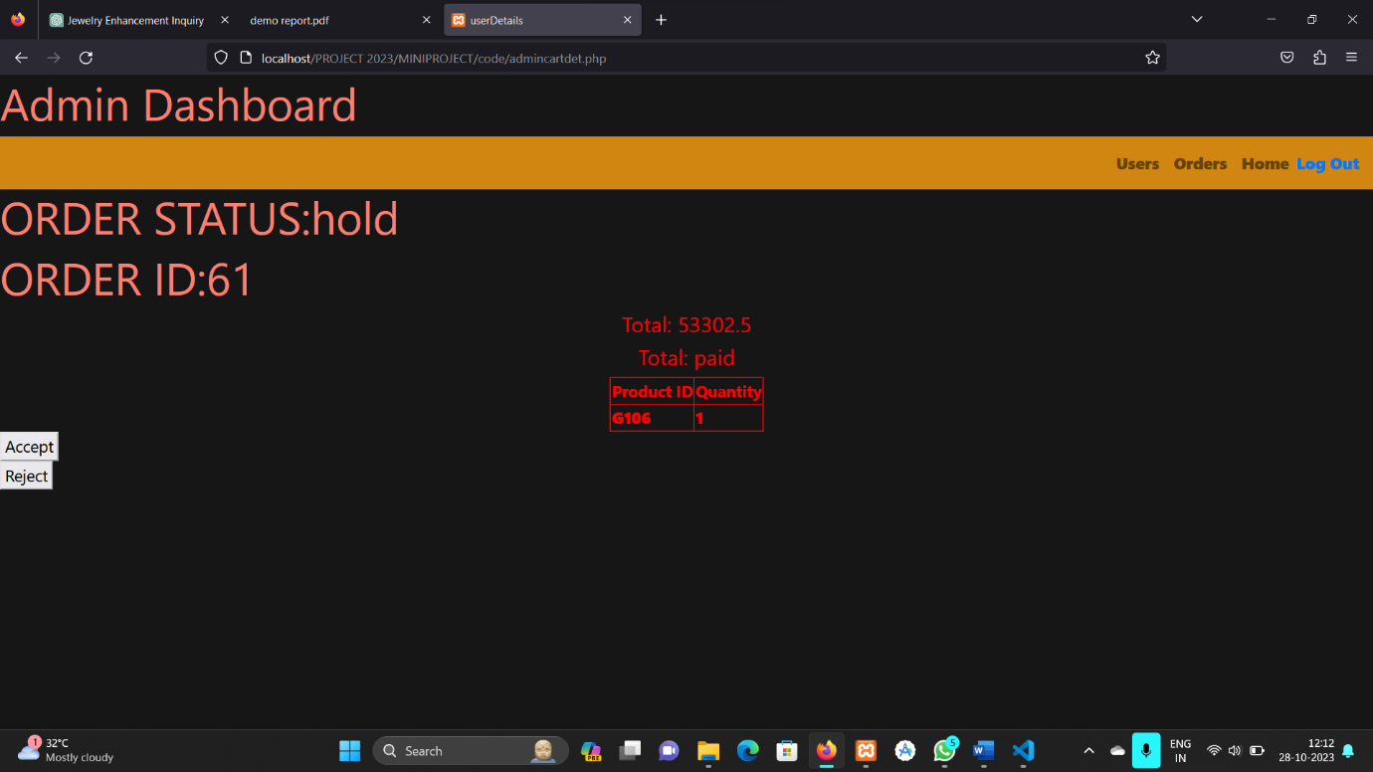

Fig 7.1.16 Product details of order

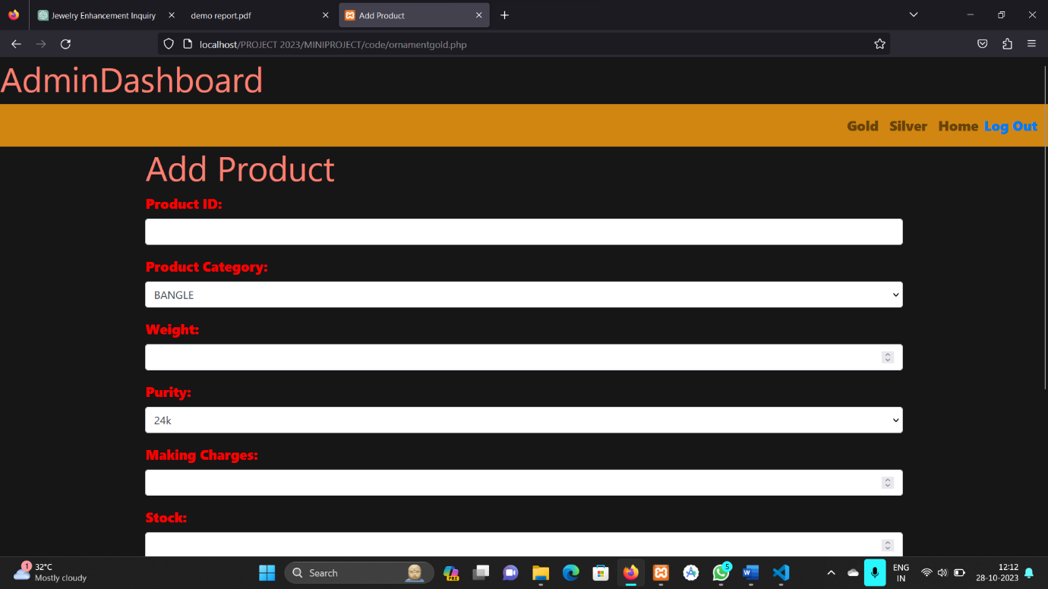

Fig 7.1.17 Product Insertion page

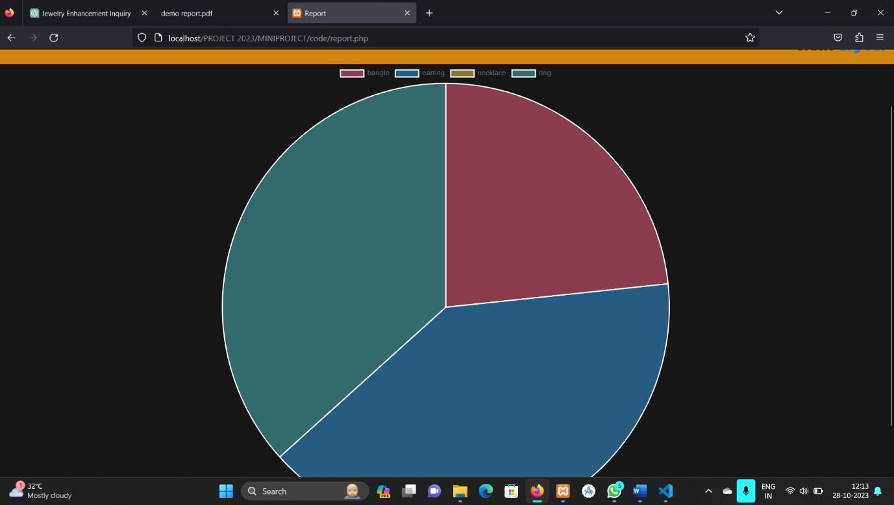

Fig 7.1.18 Pie chart sales report

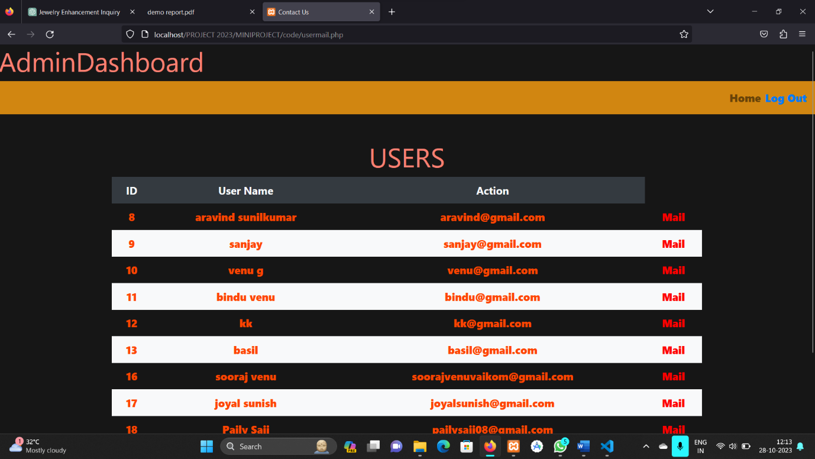

Fig 7.1.19 User details-Mail can be sent to Customers

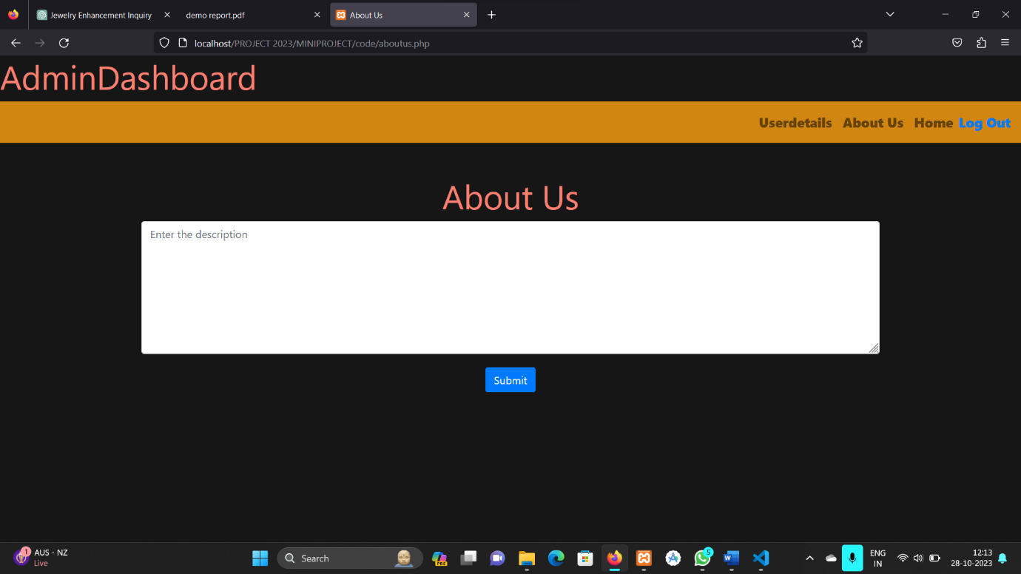

Fig 7.1.20 About us page for admin



Fig 7.1.21 Order report over two dates

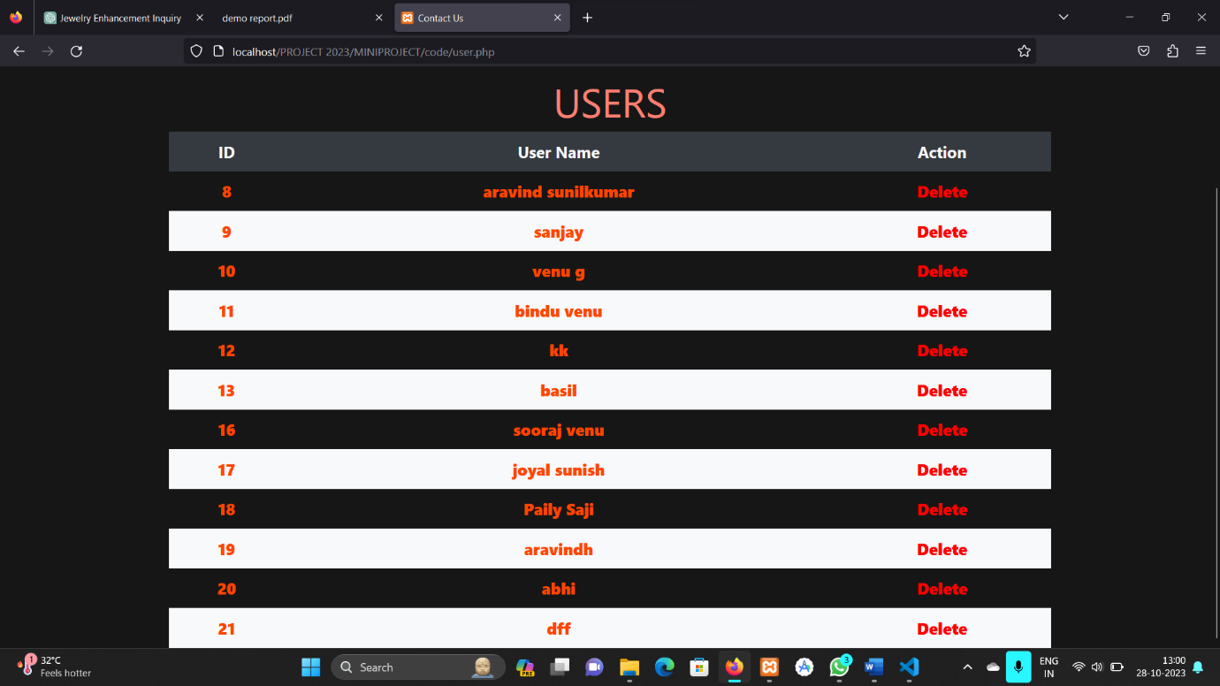

Fig 7.1.22 User details-Customers logged in

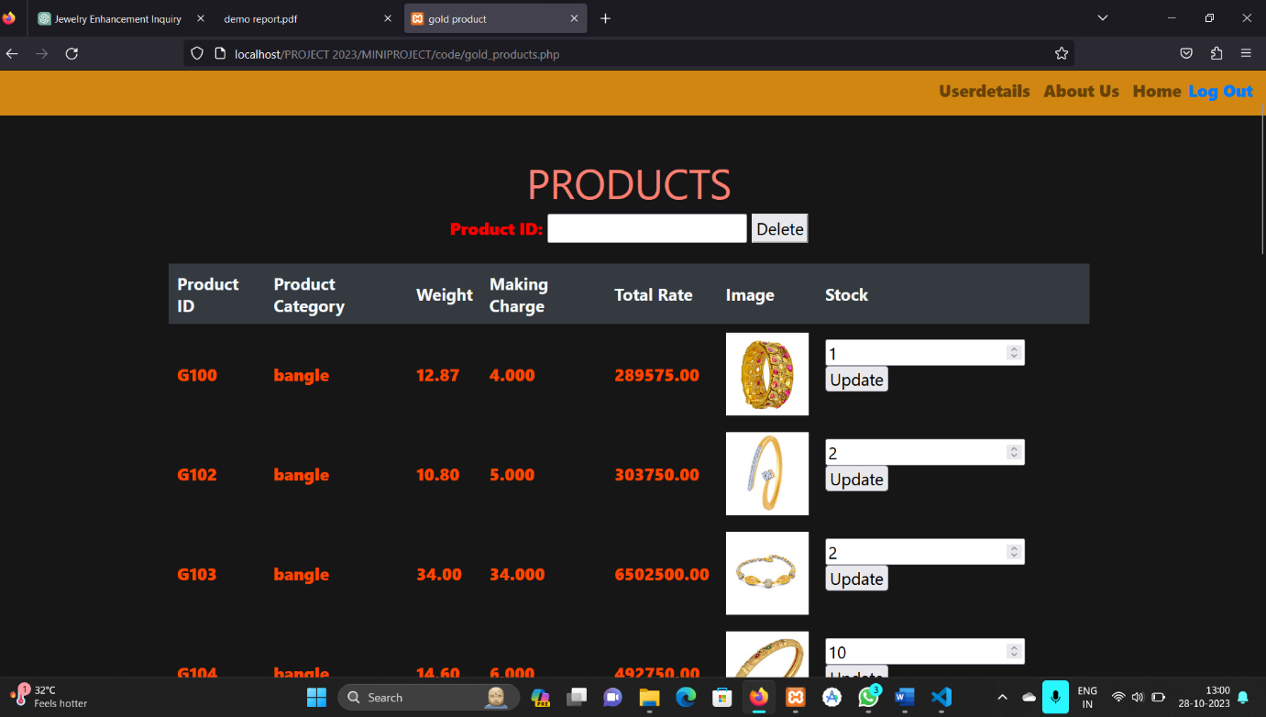

Fig 7.1.23 Gold products already inserted

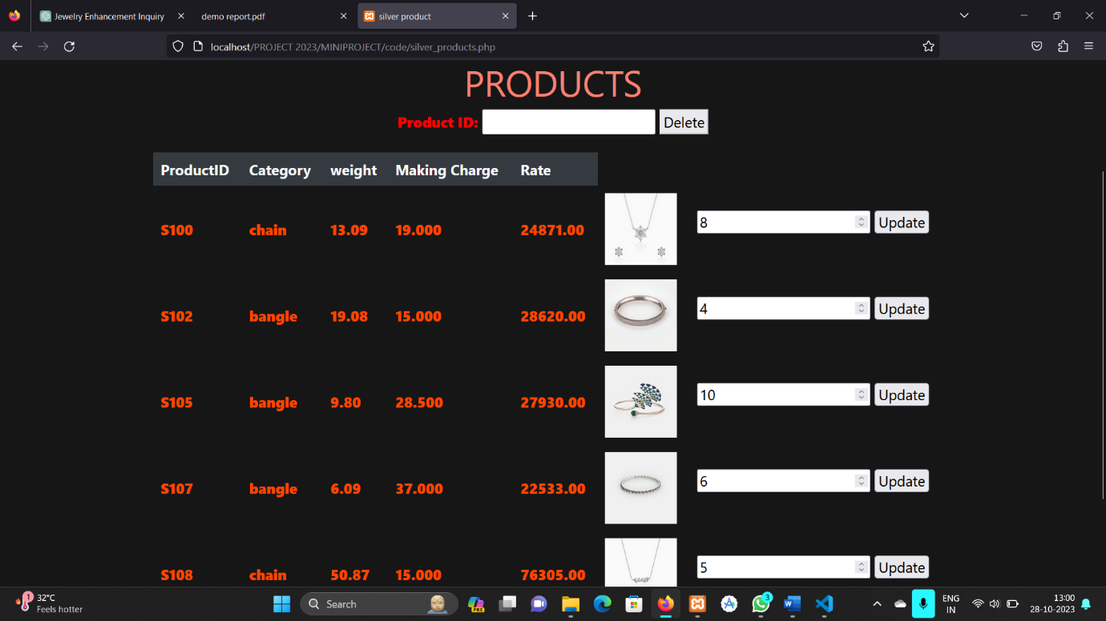

Fig 7.1.24 Silver products already inserted